CHAPTER 12
ANALYSIS OF VARIANCE TESTS

Note: Although it is possible to solve many of the problem-type exercises with a pocket calculator and formulas, statistical software with ANOVA capabilities is highly recommended.

SECTION EXERCISES
12.1 d/p/e A designed experiment is an experiment in which treatments are randomly assigned to the participants or test units.

12.2 d/p/m This statement is true when only one factor is considered in the experiment. The factor levels can then be referred to as treatments.

12.3 d/p/m For an experiment to be balanced it is necessary to have an equal number of persons or test units receiving each treatment.

12.4 d/p/m In analysis of variance, we compare between-sample variation to within-sample variation.
The basic role of the two variations is that their ratio provides the test statistic.

12.5 d/p/e In an experiment, the independent variable is the variable that is manipulated for the purpose of determining its effect on the value of the dependent variable. The dependent variable is the variable for which a value is measured or observed. The independent variable can be either quantitative or qualitative and the dependent variable is quantitative.

12.6 d/p/m This is not a random experiment since the university president has no control over which professors are in a particular college. The professors were not randomly assigned to the colleges.

12.7 d/p/m This experiment represents a designed experiment since the two treatments (methods of teaching) are randomly assigned to the students.

12.8 d/p/m This is not a designed experiment since the quality control technician has no control over which rivets the suppliers sell. The rivets were not randomly assigned to the suppliers.

12.9 d/p/m The dependent variable is the number of absences. It is a quantitative variable.
The independent variable is the college in which the professor teaches. It is a qualitative variable.

12.10 d/p/m The dependent variable is the score on the test. It is a quantitative variable.
The independent variable is the section to which the student is assigned. It is a qualitative variable.

12.11 d/p/m The dependent variable is the strength of the rivets. It is a quantitative variable.
The independent variable is the supplier. It is a qualitative variable.

12.12 d/p/e The samples don't appear to be very different from each other -- that is, the variability between the samples is small relative to the variability within the samples.

12.13 d/p/e The purpose of the one-way analysis of variance is to examine two or more independent samples to determine if their population means could be equal.

12.14 d/p/e We must assume the population distributions are normal, the population variances are equal, and the samples have been randomly and independently selected.
12.15 d/p/m The F distribution is applicable to the analysis of variance because it's the sampling distribution for the ratio of the two sample variances whenever two random samples are repeatedly drawn from the same, normally distributed population.

12.16 d/p/m
x_{ij} is the i^{th} observation for treatment j.
μ is the overall population mean for all of the treatments.
τ_{j} is the effect of treatment j.
ε_{ij} is the random error associated with the sampling process.
The null and alternative hypotheses are:
H₀: τ_{j} = 0 for treatments j = 1 through t. (Each treatment has no effect.)
H₁: τ_{j} ≠ 0 for at least one of the j = 1 through t treatments. (One or more treatments has an effect.)

12.17 d/p/m The error mean square MSE is an estimate of the variance σ² which we assume is common to all the populations.

12.18 d/p/d The effectiveness of the treatments (brands of tires) depends on the average distances traveled by the cars before stopping. All the brands are effective if the average distance traveled is small for all the brands. If the average distances traveled before stopping are equal, then the treatments (brands of tires) do not have an effect.

12.19 d/p/m If the populations in an experiment really do have the same mean, the calculated F statistic will be approximately one. This is because the two sources of variation, that between treatment means and that within treatments, are approximately equal.

12.20 c/p/e H₀: μ₁ = μ₂ = μ₃ H₁: The population means are not equal
The calculated test statistic is F = 3.95.
For this test, α = 0.05, t = 3 treatments, and N = 8 + 10 + 7 = 25. The d.f. associated with the numerator of F is v₁ = (t - 1) = (3 - 1) = 2 and the d.f. associated with the denominator of F is
v₂ = (N - t) = (25 - 3) = 22. Using the F table, the critical value is F(0.05, 2, 22) = 3.44. The decision rule is: "Reject H₀ if the calculated F > 3.44, otherwise do not reject." Since the calculated test statistic falls in the rejection region, reject H₀. Using the F tables with v₁ = 2 and v₂ = 22, p-value = P(F ≥ 3.95) is between 0.025 and 0.05.

12.21 c/p/e H₀: μ₁ = μ₂ H₁: The population means are not equal
The calculated test statistic is F = 3.60.
For this test, α = 0.05, t = 2 treatments, and N = 20 + 15 = 35. The d.f. associated with the numerator of F is v₁ = (t - 1) = (2 - 1) = 1 and the d.f. associated with the denominator of F is v₂= (N - t) =
(35 - 2) = 33. Using the F table, the critical value is F(0.05, 1, 33) = 4.17. (Since v₂ = 33 is not in the table, the closest value was used.) The decision rule is: "Reject H₀ if the calculated F > 4.17, otherwise do not reject." Since the calculated test statistic falls in the nonrejection region, do not reject H₀.
At the 0.05 level, we conclude that the population means could be equal. Using the F tables with v₁ = 1 and v₂ = 33, p-value = P(F ≥ 3.60) is greater than 0.05.

12.22 c/a/m
SST = SSE + SSTR = 252.1 + 761.1 = 1013.2
Treatments d.f. = t - 1 = 3 - 1 = 2
Error d.f. = N - t = 30 - 3 = 27
Total d.f. = N - 1 = 30 - 1 = 29
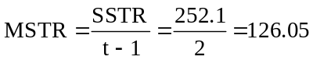, 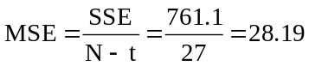, and 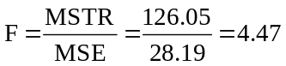

The resulting ANOVA table would look like this:
Variation Source | Sum of Squares | Degrees of Freedom | Mean Square | F
Treatment | 252.1 | 2 | 126.05 | 4.47
Error | 761.1 | 27 | 28.19
Total | 1013.2 | 29

The calculated test statistic is F = 4.47.
Using the F table, the critical value is F(0.025, 2, 27) = 4.24. The decision rule is: "Reject H₀ if the calculated F > 4.24, otherwise do not reject." Since the calculated test statistic falls in the rejection region, reject H₀. At the 0.025 level, we conclude that the population means are not equal.

12.23 p/c/m To determine if the average number of absences differ, we test:
H₀: μ₁ = μ₂ = μ₃ and H₁: The population means are not equal
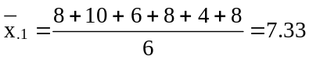, 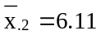, 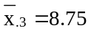; grand mean, 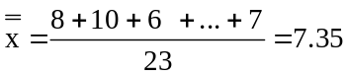

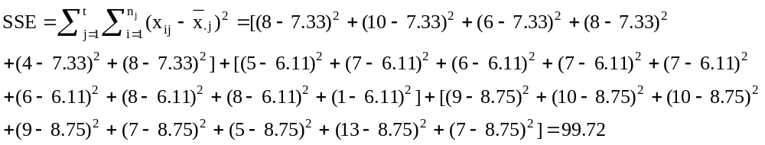

SST = SSTR + SSE = 29.52 + 99.72 = 129.24
Treatments d.f. = t - 1 = 3 - 1 = 2
Error d.f. = N - t = 23 - 3 = 20
Total d.f. = N - 1 = 23 - 1 = 22

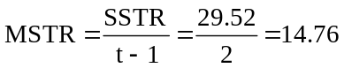, 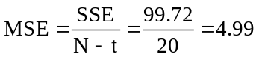, 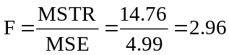

The ANOVA table is:
Variation Source | Sum of Squares | Degrees of Freedom | Mean Square | F
Treatment | 29.52 | 2 | 14.76 | 2.96
Error | 99.72 | 20 | 4.99
Total | 129.24 | 22

The calculated test statistic is F = 2.96
Using the F table, the critical value is F(0.05, 2, 20) = 3.49. The decision rule is: "Reject H₀ if the calculated F > 3.49, otherwise do not reject." Since the calculated test statistic falls in the nonrejection region, do not reject H₀. At the 0.05 level, we conclude that the average number of absences for the three colleges do not differ significantly. Using the F table with v₁ = 2 and v₂ = 20, p-value = P(F ≥ 2.96) is greater than 0.05. The Minitab printout for this problem is given below. Some values differ slightly due to rounding.

One-way ANOVA: Engineer, Business, Fine Arts
Analysis of Variance
Source DF SS MS F P
Factor 2 29.50 14.75 2.96 0.075
Error 20 99.72 4.99
Total 22 129.22
Individual 95% CIs For Mean
Based on Pooled StDev
Level N Mean StDev --+---------+---------+---------+----
Engineer 6 7.333 2.066 (-----------*-----------)
Business 9 6.111 2.147 (---------*---------)
Fine Art 8 8.750 2.435 (----------*---------)
--+---------+---------+---------+----
Pooled StDev = 2.233 4.8 6.4 8.0 9.6

The Excel counterpart is shown below:
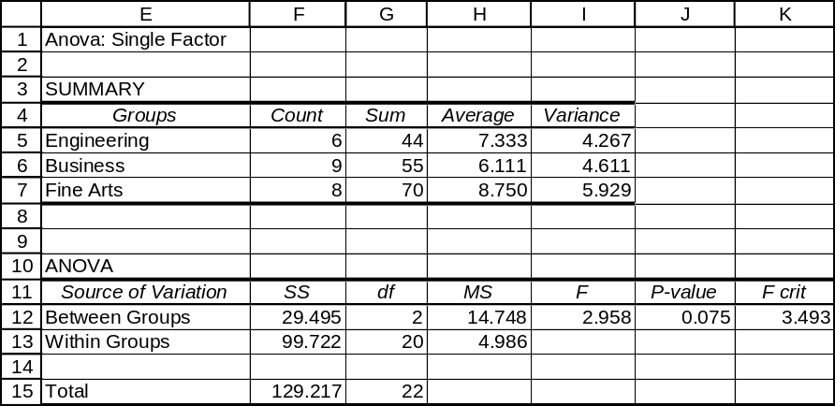

12.24 p/c/m To determine if the average scores differ for the two sections, we test:
H₀: μ₁ = μ₂ and H₁: The population means are not equal

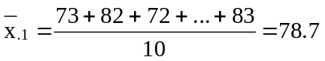, 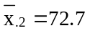, and grand mean, 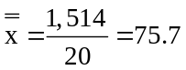

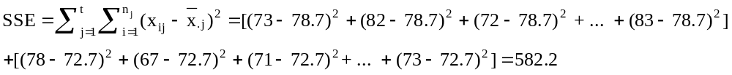

SST = SSTR + SSE = 180 + 582.2 = 762.2
Treatments d.f. = t - 1 = 2 - 1 = 1
Error d.f. = N - t = 20 - 2 = 18
Total d.f. = N - 1 = 20 - 1 = 19

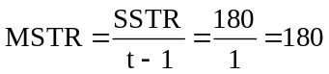, 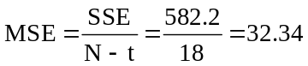, 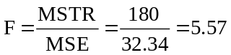

The ANOVA table is:
Variation Source | Sum of Squares | Degrees of Freedom | Mean Square | F
Treatment | 180.0 | 1 | 180.00 | 5.57
Error | 582.2 | 18 | 32.34
Total | 762.2 | 19

The calculated test statistic is F = 5.57.
Using the F table, the critical value is F(0.025, 1, 18) = 5.98. The decision rule is: "Reject H₀ if the calculated F > 5.98, otherwise do not reject." Since the calculated test statistic falls in the nonrejection region, do not reject H₀. At the 0.025 level, we conclude that the average scores for the two sections do not differ significantly. Using the F table with v₁ = 1 and v₂ = 18, p-value = P(F ≥ 5.57) is between 0.025 and 0.05. The Minitab printout for this problem is shown below:

One-way ANOVA: Used, Not Used
Analysis of Variance
Source DF SS MS F P
Factor 1 180.0 180.0 5.57 0.030
Error 18 582.2 32.3
Total 19 762.2
Individual 95% CIs For Mean
Based on Pooled StDev
Level N Mean StDev --------+---------+---------+--------
Used 10 78.700 5.964 (---------*--------)
Not Used 10 72.700 5.397 (---------*--------)
--------+---------+---------+--------
Pooled StDev = 5.687 72.0 76.0 80.0

The Excel counterpart is shown below:
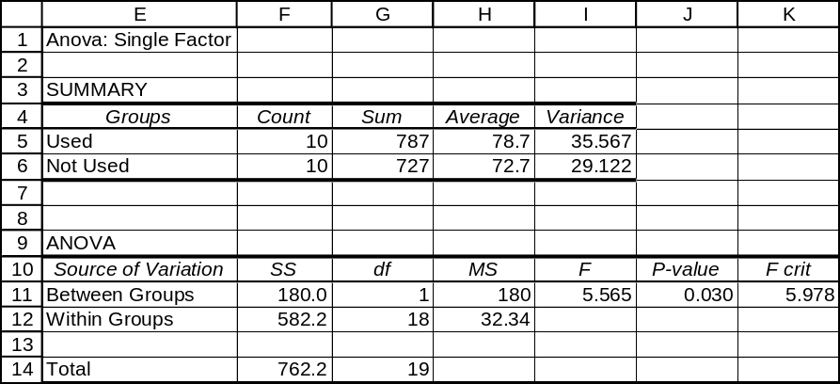

12.25 p/c/m To determine if the average breaking strengths of the rivets differ for the suppliers, we test: H₀: μ₁ = μ₂ = μ₃ = μ₄ and H₁: The population means are not equal. The Minitab printout is shown below:

One-way ANOVA: Supplier A, Supplier B, Supplier C, Supplier D
Analysis of Variance
Source DF SS MS F P
Factor 3 5709 1903 1.86 0.153
Error 36 36780 1022
Total 39 42488
Individual 95% CIs For Mean
Based on Pooled StDev
Level N Mean StDev ---------+---------+---------+-------
Supplier 10 489.70 34.82 (---------*---------)
Supplier 10 472.80 31.41 (---------*----------)
Supplier 10 464.00 30.10 (---------*---------)
Supplier 10 493.00 31.33 (----------*---------)
---------+---------+---------+-------
Pooled StDev = 31.96 460 480 500

The Excel counterpart is shown below:
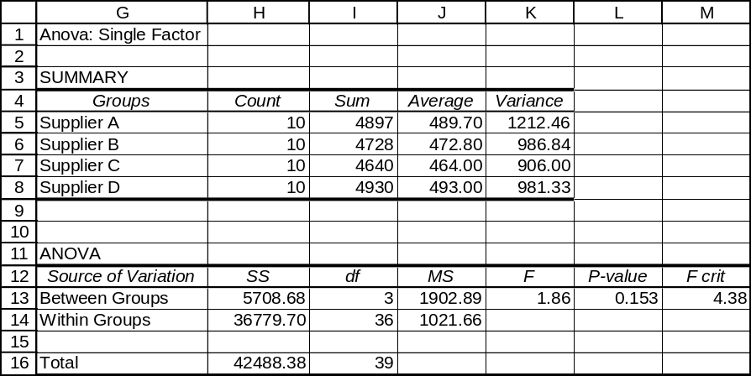

Because p-value = 0.153 is not < α = 0.01 level of significance for the test, do not reject H₀. At the 0.01 level, we conclude that the mean breaking strengths of the rivets do not differ significantly for the four suppliers.

12.26 p/c/m The null and alternative hypotheses are H₀: μ₁ = μ₂ = μ₃ = μ₄ and H₁: The population means are not equal. The Minitab printout for this problem is shown below:

One-way ANOVA: Sample1, Sample2, Sample3, Sample4
Analysis of Variance
Source DF SS MS F P
Factor 3 34.88 11.63 2.50 0.087
Error 21 97.60 4.65
Total 24 132.49
Individual 95% CIs For Mean
Based on Pooled StDev
Level N Mean StDev --------+---------+---------+--------
Sample1 5 13.340 2.364 (---------*---------)
Sample2 7 10.271 2.074 (-------*--------)
Sample3 6 12.217 1.784 (--------*--------)
Sample4 7 10.714 2.364 (--------*-------)
--------+---------+---------+--------
Pooled StDev = 2.156 10.0 12.0 14.0

The Excel printout for this problem is shown below:
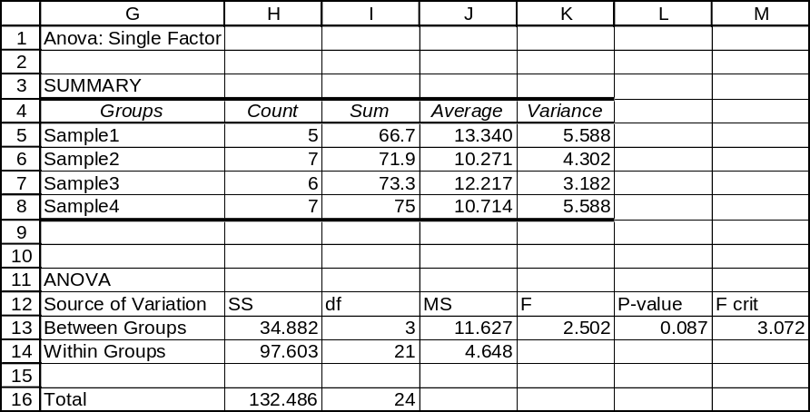

Because p-value = 0.087 is not < α = 0.05 level of significance for the test, do not reject H₀. At the 0.05 level, we conclude that the sample means do not differ significantly.
12.27 pcm The null and alternative hypotheses are H₀: μ₁ = μ₂ = μ₃ and H₁: The population means are not equal. The Minitab printout for this problem is shown below:

One-way ANOVA: Firm1, Firm2, Firm3
Analysis of Variance
Source DF SS MS F P
Factor 2 17846 8923 3.97 0.043
Error 14 31429 2245
Total 16 49275
Individual 95% CIs For Mean
Based on Pooled StDev
Level N Mean StDev ---------+---------+---------+-------
Firm1 5 223.80 40.12 (--------*--------)
Firm2 6 148.17 54.79 (--------*-------)
Firm3 6 158.50 44.68 (--------*-------)
---------+---------+---------+-------
Pooled StDev = 47.38 150 200 250

Because p-value = 0.043 is < α = 0.05 level of significance for the test, reject H₀. At the 0.05 level, we conclude that the average contributions made by the clerical workers differ for the three corporations.

12.28 p/c/m To determine if the average final examination scores differ, we test H₀: μ₁ = μ₂ and
H₁: The population means are not equal. The Minitab printout for this problem is shown below:

One-way ANOVA: GradStuA, GradStuB
Analysis of Variance
Source DF SS MS F P
Factor 1 413.9 413.9 5.25 0.036
Error 16 1260.4 78.8
Total 17 1674.3
Individual 95% CIs For Mean
Based on Pooled StDev
Level N Mean StDev ---------+---------+---------+-------
GradStuA 8 79.750 7.592 (---------*--------)
GradStuB 10 70.100 9.758 (-------*--------)
---------+---------+---------+-------
Pooled StDev = 8.876 70.0 77.0 84.0

Because p-value = 0.036 is not < α = 0.01 level of significance for the test, do not reject H₀. At the 0.01 level, the average scores of students under the different graduate students do not differ significantly.

12.29 p/c/d
a. To determine if the average lifetime differs for the three outlets, we test:
H₀: μ₁ = μ₂ = μ₃ and H₁: The population means are not equal.
b. The Minitab printout for this problem is shown below:

One-way ANOVA: 3Below, 2Below, EqLine
Analysis of Variance
Source DF SS MS F P
Factor 2 228.4 114.2 2.93 0.092
Error 12 468.0 39.0
Total 14 696.4
Individual 95% CIs For Mean
Based on Pooled StDev
Level N Mean StDev -----+---------+---------+---------+-
3Below 5 55.000 6.595 (---------*---------)
2Below 5 48.800 6.535 (---------*---------)
EqLine 5 45.600 5.550 (---------*---------)
-----+---------+---------+---------+-
Pooled StDev = 6.245 42.0 48.0 54.0 60.0

Because p-value = 0.092 is not < α = 0.01 level of significance for the test, do not reject H₀.
At the 0.01 level, we conclude that the average lifetimes of the bulbs when placed in the different outlets do not differ significantly.
c. For a confidence level of 95%, the right-tail area of interest is (1 - 0.95)/2 = 0.025 with d.f. = 12.
Referring to the t table, t = 2.179. Using the pooled estimate for the population standard deviation (6.245), we get the results below. Note: Recall that the pooled standard deviation provided by Minitab is really the square root of the MSE, or 6.245 is the square root of the 39.0 shown in the Minitab printout. Since Excel does not show this square root, it will be necessary for Excel users to first locate the MSE value, then take the square root.
The 95% confidence interval for μ₁ is:
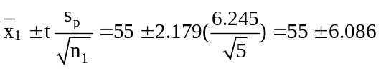 or from 48.914 to 61.086
The 95 % confidence interval for μ₂ is:
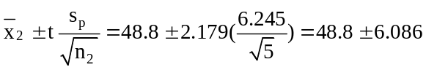 or from 42.714 to 54.886
The 95 % confidence interval for μ₃ is:
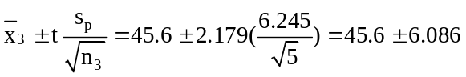 or from 39.514 to 51.686

12.30 p/c/d
a. To determine if the average speed is affected by the occupancy, we test H₀: μ₁ = μ₂ and
H₁: The population means are not equal. The Minitab printout for this problem is shown below:

One-way ANOVA: Alone, WithPass
Analysis of Variance
Source DF SS MS F P
Factor 1 251.0 251.0 3.38 0.081
Error 20 1487.0 74.4
Total 21 1738.0
Individual 95% CIs For Mean
Based on Pooled StDev
Level N Mean StDev -------+---------+---------+---------
Alone 10 63.700 9.358 (----------*-----------)
WithPass 12 56.917 7.971 (----------*---------)
-------+---------+---------+---------
Pooled StDev = 8.623 55.0 60.0 65.0

Because p-value = 0.081 is not < α = 0.025 level of significance for the test, do not reject H₀.
At the 0.025 level, we conclude that the average speed at which a car is driven is not affected by the occupancy of the vehicle.
c. For a confidence level of 95%, the right-tail area of interest is (1 - 0.95)/2 = 0.025 with d.f. = 20.
Referring to the t table, t = 2.086. Using the pooled estimate for the population standard deviation (8.623), we get the results below. Note: Recall that the pooled standard deviation provided by Minitab is really the square root of the MSE, or 8.623 is the square root of the 74.4 shown in the Minitab printout. Excel does not show the square root, so Excel users must first locate the Mean Square Error value, MSE, then take the square root.
The 95% confidence interval for μ₁ is:
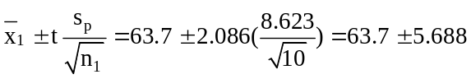 or from 58.012 to 69.388

The 95% confidence interval for μ₂ is:
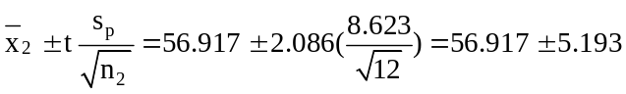 or from 51.724 to 62.110
12.31 c/a/m Error d.f. = Total d.f. - Treatments d.f. = 29 - 2 = 27
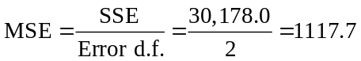 and 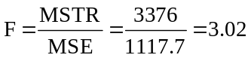

The completed ANOVA table is:
Variation Source | Sum of Squares | Degrees of Freedom | Mean Square | F
Treatment | 6752.0 | 2 | 3376.0 | 3.02
Error | 30178.0 | 27 | 1117.7
Total | 36930.0 | 29

H₀: μ₁ = μ₂ = μ₃ and H₁: The population means are not equal
The calculated test statistic is F = 3.02.
Using the F table, the critical value is F(0.05, 2, 27) = 3.35. The decision rule is: "Reject H₀ if the calculated F > 3.35, otherwise do not reject." Since the calculated test statistic falls in the nonrejection region, do not reject H₀. At the 0.05 level, we conclude that the population means are not significantly different.

12.32 c/a/m
SSE = SST - SSTR = 3736.3 - 665.0 = 3071.3
Total d.f. = Treatments d.f. + Error d.f. = 4 + 60 = 64
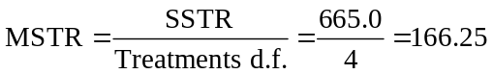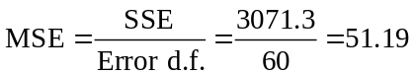

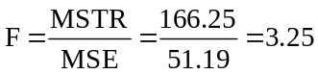

The completed ANOVA table is:
Variation Source | Sum of Squares | Degrees of Freedom | Mean Square | F
Treatment | 665.0 | 4 | 166.25 | 3.25
Error | 3071.3 | 60 | 51.19
Total | 3736.3 | 64

H₀: μ₁ = μ₂ = μ₃ = μ₄ = μ₅ and H₁: The population means are not equal
The calculated test statistic is 3.25.
Using the F table, the critical value is F(0.025, 4, 60) = 3.01. The decision rule is: "Reject H₀ if the calculated F > 3.01, otherwise do not reject." Since the calculated test statistic falls in the rejection region, reject H₀. At the 0.025 level, we conclude that the population means are not equal.

12.33 p/p/e The null and alternative hypotheses are H₀: μ₁ = μ₂ = μ₃ and H₁: The population means are not equal. The test statistic is F = 2.45 and p-value = 0.092. Interpreting the output, we can say that if the population means are equal, the probability of obtaining a test statistic this large or larger is 0.092. If the specified level of significance is less than p-value = 0.092, do not reject H₀. We would conclude that the average job-satisfaction scores for the three departments are not significantly different.

12.34 p/p/e The null and alternative hypotheses are H₀: μ₁ = μ₂ and H₁: The population means are not equal. he test statistic is F = 2.70 and the p-value = 0.111. Interpreting the output, we can say that if the population means are all equal, the probability of obtaining a test statistic this large or larger is 0.111.
If the specified level of significance is less than p-value = 0.111, do not reject H₀. We would conclude that the average incomes for male and female investment counselors are not significantly different.

12.35 c/a/m For a confidence level of 95%, the right-tail area of interest is (1 - 0.95)/2 = 0.025 with
d.f. = 92. Referring to the t table, t = 1.986. Using the pooled estimate for the population standard deviation (3.775),
The 95% confidence interval for μ₁ is:
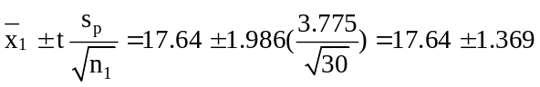 or from 16.271 to 19.009
The 95% confidence interval for μ₂ is:
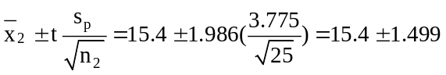 or from 13.901 to 16.899
The 95% confidence interval for μ₃ is:
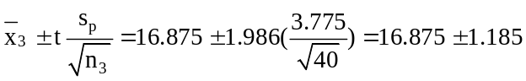 or from 15.690 to 18.060

12.36 c/a/m For a confidence level of 95%, the right-tail area of interest is (1 - 0.95)/2 = 0.025 with
d.f. = 30. Referring to the t table, t = 2.042. Using the pooled estimate for the population standard deviation (7.271),
The 95% confidence interval for μ₁ is:
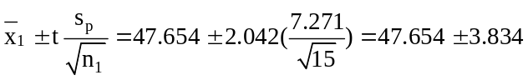 or from 43.820 to 51.488
The 95% confidence interval for μ₂ is:
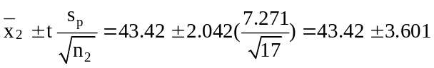 or 39.819 to 47.021

12.37 d/p/m When there are two treatments, one-way ANOVA is equivalent to the pooled-variances t-test. Each tests whether two population means could be equal, and each relies on a pooled estimate for the variance that the populations are assumed to share. In addition, both tests assume the population to be approximately normally distributed and the samples to be independent. The p-value is the same for both tests and the results are the same for a specified level of significance.

12.38 p/c/m The Minitab output below is the pooled-variances t-test for the data presented in exercise 12.28, with H₀: μ₁ = μ₂ and H₁: μ₁ ≠ μ₂:

Two-Sample T-Test and CI: GradStuA, GradStuB
Two-sample T for GradStuA vs GradStuB

N Mean StDev SE Mean
GradStuA 8 79.75 7.59 2.7
GradStuB 10 70.10 9.76 3.1

Difference = mu GradStuA - mu GradStuB
Estimate for difference: 9.65
95% CI for difference: (0.73, 18.57)
T-Test of difference = 0 (vs not =): T-Value = 2.29 P-Value = 0.036 DF = 16
Both use Pooled StDev = 8.88

From the printout, the test statistic is t = 2.29 and the p-value = 0.036. Interpreting this output, we can say that if the population means are equal, the probability of obtaining a test statistic this extreme or more extreme is 0.036. Since the p-value = 0.036 is not less than α = 0.01, do not reject H₀. At the 0.01 level, we conclude that the average scores of the students under the different graduates do not differ significantly. This is the same conclusion that was reached in exercise 12.28.
12.39 p/c/m The Minitab output below gives the pooled-variances t-test for the data of
exercise 12.30, with H₀: μ₁ = μ₂ and H₁: μ₁ ≠ μ₂:

Two-Sample T-Test and CI: Alone, WithPass
Two-sample T for Alone vs WithPass

N Mean StDev SE Mean
Alone 10 63.70 9.36 3.0
WithPass 12 56.92 7.97 2.3

Difference = mu Alone - mu WithPass
Estimate for difference: 6.78
95% CI for difference: (-0.92, 14.48)
T-Test of difference = 0 (vs not =): T-Value = 1.84 P-Value = 0.081 DF = 20
Both use Pooled StDev = 8.62

From the printout, the test statistic is t = 1.84 and the p-value = 0.081. Interpreting this output, we can say that if the population means are equal, the probability of obtaining a test statistic this extreme or more extreme is 0.081. Since the p-value = 0.081 is not less than α = 0.025, do not reject H₀. At the 0.025 level, we conclude that the average speed at which a car is driven is not affected by the occupancy of the vehicle. This is the same conclusion that was reached in exercise 12.30.

12.40 d/p/e The purpose of the randomized block design is to reduce the amount of "error" variation by ensuring that the treatment groups will be comparable in terms of the blocking variable.

12.41 d/p/e The assumptions for the randomized block design are:
1. The one observation in each treatment-block combination has been randomly selected
from a normally distributed population.
2. The variances are equal for the values in the respective populations.
3. There is no interaction between the blocks and treatments.

12.42 d/p/m In the one-way analysis of variance, the treatments are randomly assigned to the test units.
In the randomized block design, the test units are first arranged into similar groups and then the treatments are randomly assigned.

12.43 d/p/m x_{ij} = μ + τ_{j} + β_{i} + ε_{ij}
x_{ij} is an individual observation or measurement, it is the observation in the i^{th} block for treatment j.
μ is the overall population mean for all of the treatments.
τ_{j} is the effect of treatment j.
β_{i} is the effect of block i.
ε_{ij} is the random error associated with the sampling process.
Since we are only controlling for the effect of the blocking variable and not attempting to examine its influence, the hypotheses are expressed only in terms of the treatments. The null and alternative hypotheses are:
H₀: τ_{j} = 0 for treatments j = 1 through t. (Each treatment has no effect.)
H₁: τ_{j} ≠ 0 for at least one of the j = 1 through t treatments. (One or more treatments has an effect.)

12.44 d/p/e Blocking allows for a better comparison of the effect of the treatments by reducing the amount of "error" variation.

12.45 d/p/e The treatments are no longer being applied randomly to the test units. We have tampered with the randomness of the treatment groups.

12.46 c/a/m The null and alternative hypotheses are:
H₀: μ₁ = μ₂ = μ₃ and H₁: The population means are not equal.
The test statistic is F = 16.1.
For this test, α = 0.05, t = 3 treatments, and n = 2 blocks. The d.f. associated with the numerator of F is
v₁ = (t - 1) = (3 - 1) = 2 and the d.f. associated with the denominator of F is v₂ = (t - 1)(n - 1) =
(3 - 1)(2 - 1) = 2. Using the F table, the critical value is F(0.05, 2, 2) = 19.0. The decision rule is: "Reject H₀ if the calculated F > 19.0, otherwise do not reject." Since the calculated test statistic falls in the nonrejection region, do not reject H₀. At the 0.05 level, we conclude that the population means are equal. Using the F tables with v₁ = 2 and v₂ = 2, p-value = P(F ≥ 16. 1) is > 0.05.

12.47 c/a/m The null and alternative hypotheses are:
H₀: μ₁ = μ₂ = μ₃ = μ₄ = μ₅ and H₁: The population means are not equal.
The test statistic is F = 3.75.
For this test, α = 0.05, t = 5 treatments, and n = 4 blocks. The d.f. associated with the numerator of F is
v₁ = (t - 1) = (5 - 1) = 4 and the d.f. associated with the denominator of F is v₂ = (t - 1)(n - 1) =
(5 - 1)(4 - 1) = 12. Using the F table, the critical value is F(0.05, 4, 12) = 3.26. The decision rule is: "Reject H₀ if the calculated F > 3.26, otherwise do not reject." Since the calculated test statistic falls in the rejection region, reject H₀. At the 0.05 level, we conclude that the population means are not equal. Using the F tables with v₁ = 4 and v₂ = 12, p-value = P(F ≥ 3.75) is between 0.025 and 0.05.

12.48 c/a/m
SST = SSTR + SSB + SSE = 394.0 + 325.0 + 180.0 = 899.0
Treatments d.f. = t - 1 = 3 - 1 = 2
Blocks d.f. = n - 1 = 3 - 1 = 2
Error d.f. = (t - 1)(n - 1) = (3 - 1)(3 - 1) = 4
Total d.f. = tn - 1 = 3(3) - 1 = 8
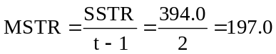, 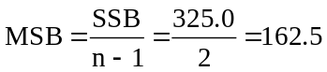, 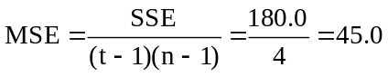

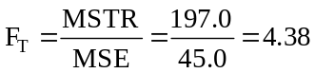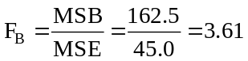

The ANOVA table is:
Variation Source | Sum of Squares | Degrees of Freedom | Mean Square | F
Treatment | 394.0 | 2 | 197.0 | 4.38
Blocks | 325.0 | 2 | 162.5 | 3.61
Error | 180.0 | 4 | 45.0
Total | 899.0 | 8

H₀: τ_{j} = 0 for treatments j = 1, 2, 3 and H₁: τ_{j} ≠ 0 for at least one of the treatments
The calculated test statistic is F = 4.38.
Using the F table, the critical value is F(0.05, 2, 4) = 6.94. The decision rule is: "Reject H₀ if the calculated F > 6.94, otherwise do not reject." Since the calculated test statistic falls in the nonrejection region, do not reject H₀. At the 0.05 level, we conclude that all the treatment effects could be zero.

12.49 c/c/m To illustrate how the process works, we will first show the solution as it would come about from use of the formulas and a pocket calculator:
 | Treatment 1 | Treatment 2
Block A | 46 | 31 | 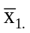= 38.5
Block B | 37 | 26 | 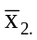= 31.5
Block C | 44 | 35 | 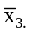= 39.5
 | 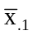 = 42.33 | 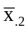= 30.67

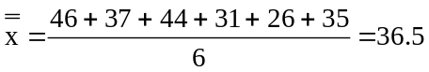

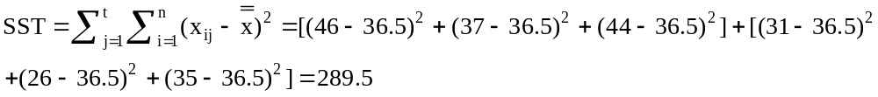

SSE = SST - SSTR - SSB = 289.5 - 203.93 - 76 = 9.57
Treatments d.f. = t - 1 = 2 - 1 = 1
Blocks d.f. = n - 1 = 3 - 1 = 2
Error d.f. = (t - 1)(n - 1) = (2 - 1)(3 - 1) = 2
Total d.f. = tn - 1 = 2(3) - 1 = 5

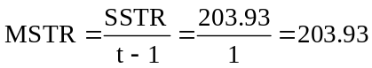 and 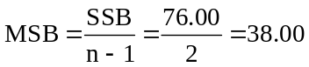

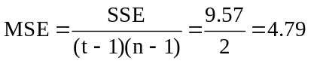

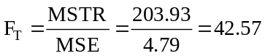 and 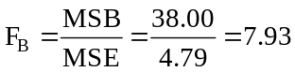

The ANOVA table is:
Variation Source | Sum of Squares | Degrees of Freedom | Mean Square | F
Treatments | 203.93 | 1 | 203.93 | 42.57
Blocks | 76.00 | 2 | 38.00 | 7.93
Error | 9.57 | 2 | 4.79
Total | 289.50 | 5

Testing for treatment effects:
H₀: τ_{j} = 0 for treatments j = 1, 2 and H₁: τ_{j} ≠ 0 for at least one of the treatments
The calculated test statistic is 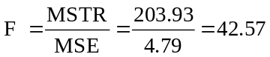

Using the F table, the critical value is F(0.01, 1, 2) = 98.5. The decision rule is: "Reject H₀ if the calculated F > 98.5, otherwise do not reject." Since the calculated test statistic falls in the nonrejection region, do not reject H₀. As shown in the Minitab and Excel printouts for this exercise, the p-value for the test of treatment effects is 0.022.

Testing for block effects:
H₀: β_{i} = 0 for i = 1, 2, 3 (the levels of the blocking variable are equal in their effect)
H₁: β_{i} ≠ 0 for at least one value of i (at least one level has an effect different from the others)
For the block effects, the calculated test statistic is 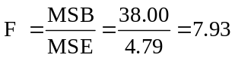
Using the F table, the critical value is F(0.01, 2, 2) = 99.0. The decision rule is: "Reject H₀ if the calculated F > 99.00, otherwise do not reject." Since the calculated test statistic falls in the nonrejection region, do not reject H₀. At the 0.01 level, we conclude that all of the block effects could be zero.
As shown in the Minitab and Excel printouts below, the p-value for the test of block effects is 0.109. First, the Minitab data layout and printout:

Row Block Treat x
1 1 1 46
2 1 2 31
3 2 1 37
4 2 2 26
5 3 1 44
6 3 2 35

Two-way ANOVA: x versus Block, Treat
Analysis of Variance for x
Source DF SS MS F P
Block 2 76.00 38.00 8.14 0.109
Treat 1 204.17 204.17 43.75 0.022
Error 2 9.33 4.67
Total 5 289.50

This is the Excel printout for this exercise. Some values may be slightly different because of rounding.
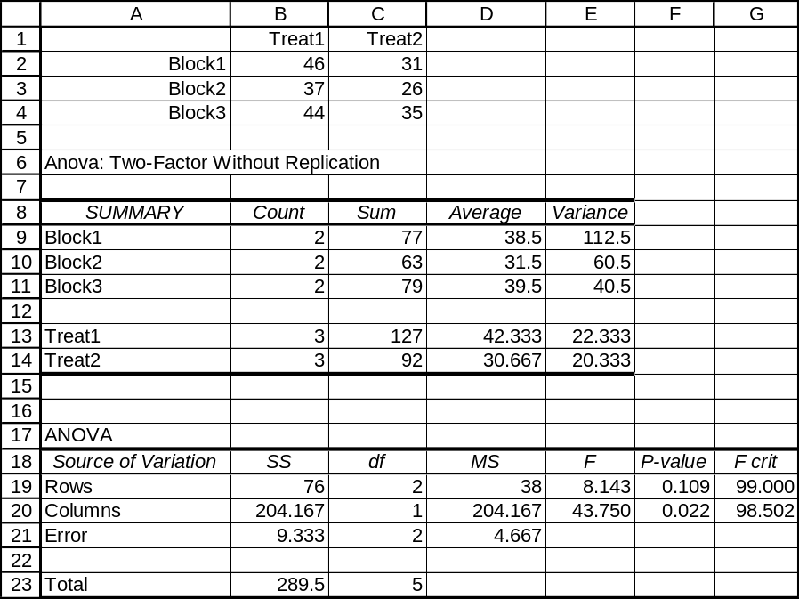

12.50 c/c/m The Minitab printout for this exercise is shown below:

Two-way ANOVA: x versus Block, Treat
Analysis of Variance for x
Source DF SS MS F P
Block 4 1047.88 261.97 55.13 0.000
Treat 3 75.49 25.16 5.30 0.015
Error 12 57.02 4.75
Total 19 1180.40

Testing for treatment effects:
H₀: τ_{j} = 0 for treatments j = 1, 2, 3, 4 and H₁: τ_{j} ≠ 0 for at least one of the treatments
The calculated test statistic is: 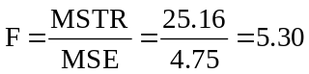

Using the F table, the critical value is F(0.05, 3, 12) = 3.49. The decision rule is: "Reject H₀ if the calculated F > 3.49, otherwise do not reject." Since the calculated test statistic falls in the rejection region (F = 5.30 > 3.49), reject H₀. At the 0.05 level, we conclude that the treatment effects are not all zero. As shown in the Minitab printout, the p-value for the test of treatment effects is 0.015.

Testing for block effects:
H₀: β_{i} = 0 for i = 1, 2, 3, 4, 5 (the levels of the blocking variable are equal in their effect)
H₁: β_{i} ≠ 0 for at least one value of i (at least one level has an effect different from the others)
For the block effects, the calculated test statistic is: 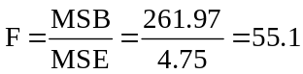

Using the F table, the critical value is F(0.01, 4, 12) = 5.41. The decision rule is: "Reject H₀ if the calculated F > 5.41, otherwise do not reject." Since the calculated test statistic falls in the rejection region, reject H₀. At the 0.01 level, we conclude at least one of the block effects is not zero. (At least one block has an effect different from the others.) As shown in the printout, the p-value for the test of block effects is, to three decimal places, 0.000.
The Excel printout corresponding to this exercise is shown below. Due to rounding, some values may vary slightly from those presented earlier. Again, the p-value for the treatment (shown here as columns) effect is p-value = 0.015. The p-value for the block (identified here as rows) effect is, rounded to three decimal places, p-value = 0.000.
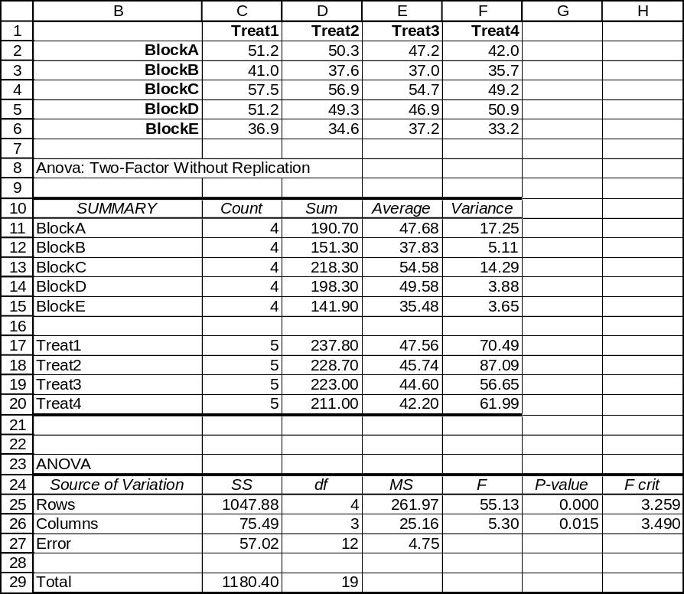

12.51 p/c/m For this problem, the three battery brands are the treatments and the four toys are the blocks. The Minitab printout is shown below:

Two-way ANOVA: Time versus Block, Treatmnt
Analysis of Variance for Time
Source DF SS MS F P
Block 3 6.716 2.239 3.90 0.074
Treatmnt 2 7.227 3.613 6.29 0.034
Error 6 3.447 0.574
Total 11 17.389

Testing for treatment effects:
To determine if the battery treatment effects could all be zero, we test:
H₀: τ_{j} = 0 for treatments j = 1, 2, 3 and H₁: τ_{j} ≠ 0 for at least one of the treatments
The calculated test statistic is: 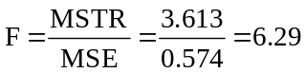

Using the F table, the critical value is F(0.025, 2, 6) = 7.26. The decision rule is: "Reject H₀ if the calculated F > 7.26, otherwise do not reject." Since the calculated test statistic falls in the nonrejection region, do not reject H₀. At the 0.025 level, we conclude that the battery treatment effects could all be zero. Therefore, at the 0.025 level, the batteries are equally effective. As shown in the Minitab printout, the p-value for the test of treatment effects is 0.034.

Testing for block effects:
H₀: β_{i} = 0 for i = 1, 2, 3, 4 (the levels of the blocking variable are equal in their effect)
H₁: β_{i} ≠ 0 for at least one value of i (at least one level has an effect different from the others)
For the block effect, the calculated test statistic is: 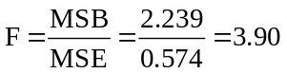

Using the F table, the critical value is F(0.01, 3, 6) = 9.78. The decision rule is: "Reject H₀ if the calculated F > 9.78, otherwise do not reject." Since the calculated test statistic falls in the nonrejection region, do not reject H₀. At the 0.01 level, we conclude that all of the block effects could be zero.
As shown in the Minitab printout, the p-value for the test of block effects is 0.074.

Shown below is the Excel printout corresponding to this exercise. Once again, the p-value for the treatment (identified here as rows or batteries) effect is 0.034, and the p-value for the block (identified here as columns, or toy types) effect is 0.074.
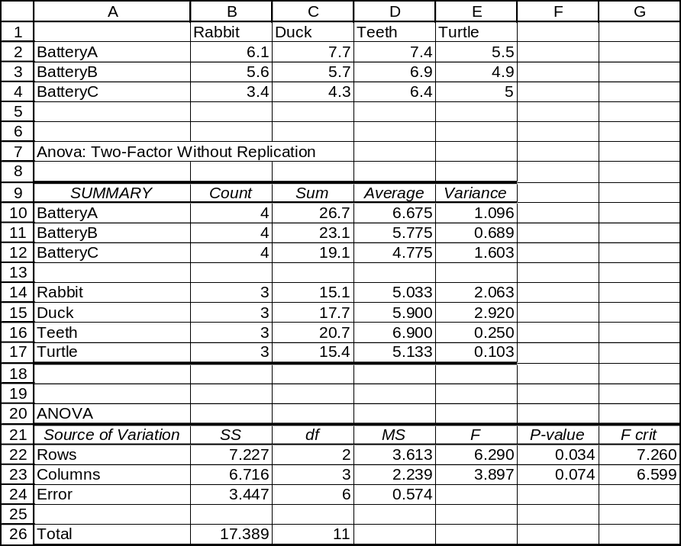

12.52 p/c/m For this problem, the five racquet models are the treatments and the three skill levels are the blocks. The Minitab printout is shown below:

Two-way ANOVA: mph versus Skill, Racquet
Analysis of Variance for mph
Source DF SS MS F P
Skill 2 1332.1 666.1 13.44 0.003
Racquet 4 1056.7 264.2 5.33 0.022
Error 8 396.5 49.6
Total 14 2785.3

Testing for treatment effects:
To determine if the racquet treatment effects could all be zero, we test:
H₀: τ_{j} = 0 for treatments j = 1, 2, 3, 4, 5 and H₁: τ_{j} ≠ 0 for at least one of the treatments
The calculated test statistic is: 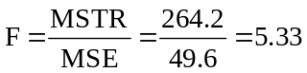

Using the F table, the critical value is F(0.025, 4, 8) = 5.05. The decision rule is: "Reject H₀ if the calculated F > 5.05, otherwise do not reject." Since the calculated test statistic falls in the rejection region, reject H₀. At the 0.025 level, we conclude that the treatment effects of the five racquets are not all zero. Therefore, at the 0.025 level, the racquet models are not equally effective. As shown in the Minitab printout, the p-value for the test of treatment effects is 0.022.

Testing for block effects:
H₀: β_{i} = 0 for i = 1, 2, 3 (the levels of the blocking variable are equal in their effect)
H₁: β_{i} ≠ 0 for at least one value of i (at least one level has an effect different from the others)
For the block effect, the calculated test statistic is: 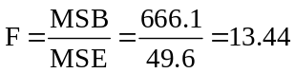

Using the F table, the critical value is F(0.01, 2, 8) = 8.65. The decision rule is: "Reject H₀ if the calculated F > 8.65, otherwise do not reject." Since the calculated test statistic falls in the rejection region, reject H₀. At the 0.01 level, we conclude that at least one of the block effects is not zero.
At least one block, or skill level, has an effect different from the others. As shown in the Minitab printout, the p-value for the test of block effects is 0.003.

12.53 p/c/m For this problem, the two control-button configurations are the treatments and the seven
operators are the blocks. To determine if the button treatment effects could both be zero, we test:
H₀: τ_{j} = 0 for treatments j = 1, 2 and H₁: τ_{j} ≠ 0 for at least one of the treatments. A condensed version of the Excel printout is shown below:
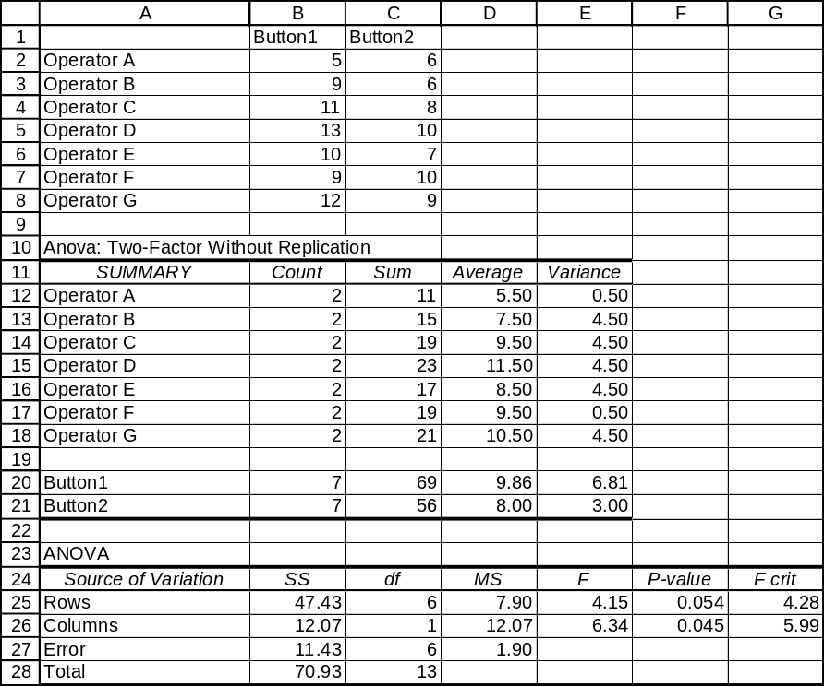
The p-value for the treatment (identified here as columns or button configurations) effect is p-value = 0.045. Since p-value = 0.045 is < α = 0.05 level of significance for the test, we reject H₀. At the 0.05 level, we conclude that the treatment effects of the two layouts are not both zero, and that the two configurations are not equally effective.

12.54 c/a/m
Error d.f. = 8 - (2 + 2) = 4

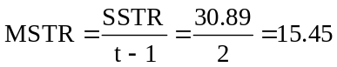, 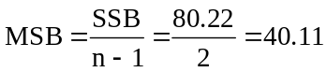, 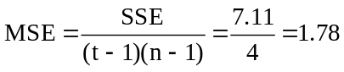

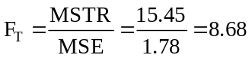 and 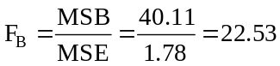

The completed ANOVA table is:
Variation Source | Sum of Squares | Degrees of Freedom | Mean Square | F
Treatments | 30.89 | 2 | 15.45 | 8.68
Blocks | 80.22 | 2 | 40.11 | 22.53
Error | 7.11 | 4 | 1.78
Total | 118.22 | 8

The null and alternative hypotheses are:
H₀: τ_{j} = 0 for treatments j = 1, 2, 3 and H₁: τ_{j} ≠ 0 for at least one of the treatments.
The calculated test statistic is F = 8.68. Using the F table, the critical value is F(0.025, 2, 4) = 10.65.
The decision rule is: "Reject H₀ if the calculated F > 10.65, otherwise do not reject." Since the calculated test statistic falls in the nonrejection region, do not reject H₀. At the 0.025 level, we conclude that all of the treatment effects are zero. Therefore, the treatments are equally effective.

12.55 c/a/m
Treatments d.f. = 14 - (2 + 8) = 4

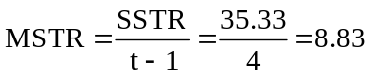, 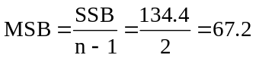, 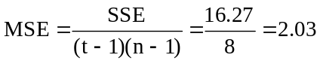

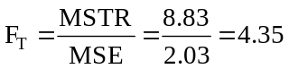 and 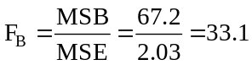

The completed ANOVA table is:
Variation Source | Sum of Squares | Degrees of Freedom | Mean Square | F
Treatments | 35.33 | 4 | 8.83 | 4.35
Blocks | 134.40 | 2 | 67.20 | 33.10
Error | 16.27 | 8 | 2.03
Total | 186.00 | 14

The null and alternative hypotheses are:
H₀: τ_{j} = 0 for treatments j = 1, 2, 3, 4, 5 and H₁: τ_{j} ≠ 0 for at least one of the treatments.

The calculated test statistic is F = 4.35. Using the F table, the critical value is F(0.05, 4, 8) = 3.84.
The decision rule is: "Reject H₀ if the calculated F > 3.84, otherwise do not reject." Since the calculated test statistic falls in the rejection region, reject H₀. At the 0.05 level, we conclude that all of the treatment effects are not zero. Therefore, the treatments are not equally effective.

12.56 p/a/m The treatments are the three different types of appeals. The null and alternative hypotheses are H₀: τ_{j} = 0 for treatments j = 1, 2, and 3, and H₁: τ_{j} ≠ 0 for at least one of the treatments. The p-value for the test of treatment effects is 0.031.
Since p-value = 0.031 is not < α = 0.025, the level of significance used in reaching our conclusion, we do not reject H₀, and we conclude that the treatments are equally effective. On the other hand, the test of block effects has a p-value of just 0.012. Since p-value = 0.012 is < α = 0.025, we conclude that the blocks (income categories) are not equal in their effect.

12.57 d/p/m The randomized block ANOVA with two treatments and the dependent-samples t-test of Chapter 11 are equivalent. The assumptions are the same for both procedures and the results will be the same at a specified level of significance.

12.58 c/c/m In applying the dependent-samples t-test to the data in exercise 12.49, the difference within each block will be d = x₁ - x₂. The null and alternative hypotheses will be H₀: μ_{d} = 0 and H₁: μ_{d} ≠ 0.
The Minitab printout is shown below:

Paired T-Test and CI: Treat1, Treat2
Paired T for Treat1 - Treat2
N Mean StDev SE Mean
Treat1 3 42.33 4.73 2.73
Treat2 3 30.67 4.51 2.60
Difference 3 11.67 3.06 1.76

95% CI for mean difference: (4.08, 19.26)
T-Test of mean difference = 0 (vs not = 0): T-Value = 6.61 P-Value = 0.022

Interpreting this output, we can say that if the population means were equal, the probability of obtaining a test statistic this extreme or more extreme is 0.022. Since the p-value = 0.022 is not less than α = 0.01,
do not reject H₀. At the 0.01 level, we conclude that the population means could be equal. This is the same conclusion that was reached in exercise 12.49.

12.59 p/c/m In applying the dependent-samples t-test to the data in exercise 12.53, the difference within each block will be d = x₁ - x₂. The null and alternative hypotheses will be H₀: μ_{d} = 0 and H₁: μ_{d} ≠ 0.
The Minitab printout is shown below:

Paired T-Test and CI: Button1, Button2
Paired T for Button1 - Button2
N Mean StDev SE Mean
Button1 7 9.857 2.610 0.986
Button2 7 8.000 1.732 0.655
Difference 7 1.857 1.952 0.738

95% CI for mean difference: (0.052, 3.663)
T-Test of mean difference = 0 (vs not = 0): T-Value = 2.52 P-Value = 0.045

Interpreting this output, we can say that if the population means were equal, the probability of obtaining a test statistic this extreme or more extreme is 0.045. Since the p-value = 0.045 is less than α = 0.05, reject H₀. At the 0.05 level, we conclude that the population means are not equal. This is the same conclusion that was reached in exercise 12.53.

12.60 d/p/m The purpose of two-way analysis of variance is to simultaneously examine the effects of two factors on a dependent variable and the effect of interactions between the different levels of these two factors.

12.61 d/p/m We assume the r observations in each cell have been drawn from normally distributed populations with equal variances.

12.62 d/p/m In the two-way analysis of variance we are interested in the effect of two factors and their interaction on the dependent variable. Therefore, we test for each factor effect and for interaction.
In the one-way analysis of variance and the randomized block designs, we are interested in only one factor effect.

12.63 d/p/m The two-way analysis of variance and the randomized block design are similar since they both consider two factors in the model. However, in the randomized block design, the blocking variable is only used for the purpose of exerting improved control over the examination of the single factor of interest. In two-way analysis of variance, we are interested in the effects of two factors and their interaction on the dependent variable.

12.64 d/p/m The main effect is an effect caused by one of the factors in the experiment. The interactive effect is the effect that results from the combination of a level of one factor with a level of another factor.

12.65 d/p/e Replications refers to the number of persons or test units within each cell. Within each combination of levels, there will be k = 1 through r observations or replications.

12.66 c/p/e There are 4 x 3 = 12 treatments. A treatment consists of a combination of one level of factor A and one level of factor B.

12.67 d/p/m
x_{ijk} = μ + α_{i} +β_{j} + (αβ)_{ij} + ε_{ijk}
x_{ijk} is the k^{th} observation within the i^{th} level for Factor A and the j^{th} level for Factor B.
μ is the overall population mean.
α_{i} is the effect of the i^{th} level of Factor A.
β_{j} is is the effect of the j^{th} level of Factor B.
(αβ)_{ij} is the effect of the interaction between the i^{th} level of Factor A and the j^{th} level of Factor B.
ε_{ijk} is the random error associated with the sampling process.

There are three sets of null and alternative hypotheses to be tested.
1. Testing for main effects, Factor A
H₀: α_{i} = 0 for each level of Factor A, i = 1 through a. (No level of Factor A has an effect.)
H₁: α_{i} ≠ 0 for at least one value of i. (At least one level of Factor A has an effect.)
2. Testing for main effects, Factor B
H₀: β_{j} = 0 for each level of Factor B, j = 1 through b. (No level of Factor B has an effect.)
H₁: β_{j} ≠ 0 for at least one value of j. (At least one level of Factor B has an effect.)
3. H₀: (αβ)_{ij} = 0 for each combination of i and j. (There are no interaction effects.)
H₁: (αβ)_{ij} ≠ 0 for at least one combination of i and j. (There is at least one interaction effect.)

12.68 c/a/m
Testing for Main Effects, Factor A.
H₀: α_{i} = 0 for each value of i, i = 1 through 3
H₁: α_{i} ≠ 0 for at least one value of i
The calculated test statistic is 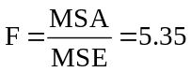
For this test, α = 0.05, a = 3, b = 2, and r = 2. The d.f. associated with the numerator of F is
v₁ = a - 1 = 3 - 1 = 2 and the d.f. associated with the denominator of F is v₂ = ab(r - 1) =
3(2)(2 - 1) = 6. Using the F table, the critical value is F(0.05, 2, 6) = 5.14. The decision rule is: "Reject H₀ if the calculated F > 5.14, otherwise do not reject." Since the calculated test statistic falls in the rejection region, reject H₀. At the 0.05 level, we conclude that at least one level of Factor A has an effect.

Testing for Main Effects, Factor B.
H₀: β_{j} = 0 for each value of j, j = 1 through 2
H₁: β_{j} ≠ 0 for at least one value of j
The test statistic is 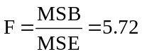
For this test, α = 0.05, a = 3, b = 2, and r = 2. The d.f. associated with the numerator of F is
v₁ = b - 1 = 2 - 1 = 1 and the d.f. associated with the denominator of F is v₂ = ab(r - 1) = 6. Using the F table, the critical value is F(0.05, 1, 6) = 5.99. The decision rule is: "Reject H₀ if the calculated F > 5.99, otherwise do not reject." Since the calculated test statistic falls in the nonrejection region, do not reject H₀. At the 0.05 level, we conclude that no level of Factor B has an effect.

Testing for Interaction Effects
H₀: (αβ)_{ij} = 0 for each combination of i and j
H₁: (αβ)_{ij} ≠ 0 for at least one combination of i and j
The test statistic is 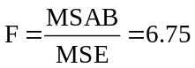
For this test, α = 0.05, a = 3, b = 2, and r = 2. The d.f. associated with the numerator of F is
v₁ = (a - 1)(b - 1) = (3 - 1)(2 - 1) = 2 and the d.f. associated with the denominator of F is
v₂ = ab(r - 1) = 6. Using the F table, the critical value is F(0.05, 2, 6) = 5.14. The decision rule is: "Reject H₀ if the calculated F > 5.14, otherwise do not reject." Since the calculated test statistic falls in the rejection region, reject H₀. At the 0.05 level, we conclude that there is some relationship between the levels of Factor A and Factor B.

12.69 c/a/m
Testing for Main Effects, Factor A.
H₀: α_{i} = 0 for each value of i, i = 1 through 4
H₁: α_{i} ≠ 0 for at least one value of i
The calculated test statistic is 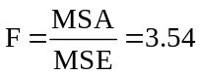
For this test, α = 0.025, a = 4, b = 3, and r = 3. The d.f. associated with the numerator of F is
v₁ = a - 1 = 4 - 1 = 3 and the d.f. associated with the denominator of F is v₂ = ab(r - 1) = 4(3)(3 - 1) = 24. Using the F table, the critical value is F(0.025, 3, 24) = 3.72. The decision rule is: "Reject H₀ if the calculated F > 3.72, otherwise do not reject." Since the calculated test statistic falls in the nonrejection region, do not reject H₀. At the 0.025 level, we conclude that no level of Factor A has an effect.

Testing for Main Effects, Factor B.
H₀: β_{j} = 0 for each value of j, j = 1 through 3
H₁: β_{j} ≠ 0 for at least one value of j
The test statistic is 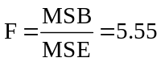
For this test, α = 0.025, a = 4, b = 3, and r = 3. The d.f. associated with the numerator of F is
v₁ = b - 1 = 3 - 1 = 2 and the d.f. associated with the denominator of F is v₂ = ab(r - 1) = 24. Using the F table, the critical value is F(0.025, 2, 24) = 4.32. The decision rule is: "Reject H₀ if the calculated
F > 4.32, otherwise do not reject." Since the calculated test statistic falls in the rejection region, reject H₀. At the 0.025 level, we conclude that at least one level of Factor B has an effect.

Testing for Interaction Effects
H₀: (αβ)_{ij} = 0 for each combination of i and j
H₁: (αβ)_{ij} ≠ 0 for at least one combination of i and j
The test statistic is 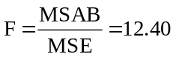
For this test, α = 0.025, a = 4, b = 3, and r = 3. The d.f. associated with the numerator of F is
v₁ = (a - 1)(b - 1) = (4 - 1)(3 - 1) = 6 and the d.f. associated with the denominator of F is
v₂ = ab(r - 1) = 24. Using the F table, the critical value is F(0.025, 6, 24) = 2.99. The decision rule is: "Reject H₀ if the calculated F > 2.99, otherwise do not reject." Since the calculated test statistic falls in the rejection region, reject H₀. At the 0.025 level, we conclude that there is some relationship between the levels of Factor A and Factor B.

12.70 c/a/d
SST = SSA + SSB + SSAB + SSE = 89.58 + 30.17 + 973.08 + 29.00 = 1121.83
A d.f. = a - 1 = 3 - 1 = 2
B d.f. = b - 1 = 4 - 1 = 3
AB d.f. = (a - 1)(b - 1) = (2)(3) = 6
Error d.f. = ab(r - 1) = 3(4)(2 - 1) = 12
Total d.f. = abr - 1 = 3(4)(2) - 1 = 23

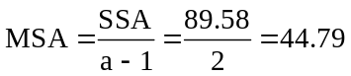, 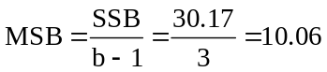

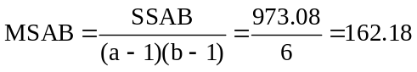, 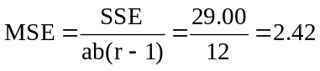

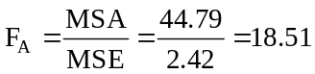, 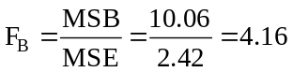, 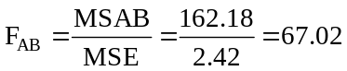

The ANOVA table is:
Variation Source | Sum of Squares | Degrees of Freedom | Mean Square | F
Factor A | 89.58 | 2 | 44.79 | 18.51
Factor B | 30.17 | 3 | 10.06 | 4.16
Interaction, AB | 973.08 | 6 | 162.18 | 67.02
Error | 29.00 | 12 | 2.42
Total | 1121.83 | 23

Testing for Main Effects, Factor A.
H₀: α_{i} = 0 for each value of i, i = 1 through 3
H₁: α_{i} ≠ 0 for at least one value of i
The calculated test statistic is 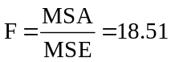
Using the F table, the critical value is F(0.05, 2, 12) = 3.89. The decision rule is: "Reject H₀ if the calculated F > 3.89, otherwise do not reject." Since the calculated test statistic falls in the rejection region, reject H₀. At the 0.05 level, we conclude that at least one level of Factor A has an effect.

Testing for Main Effects, Factor B.
H₀: β_{j} = 0 for each value of j, j = 1 through 4
H₁: β_{j} ≠ 0 for at least one value of j
The test statistic is 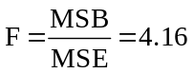
Using the F table, the critical value is F(0.05, 3, 12) = 3.49. The decision rule is: "Reject H₀ if the calculated F > 3.49, otherwise do not reject." Since the calculated test statistic falls in the rejection region, reject H₀. At the 0.05 level, we conclude that at least one level of Factor B has an effect.

Testing for Interaction Effects
H₀: (αβ)_{ij} = 0 for each combination of i and j
H₁: (αβ)_{ij} ≠ 0 for at least one combination of i and j
The test statistic is 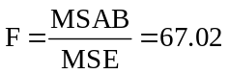
Using the F table, the critical value is F(0.05, 6, 12) = 3.00. The decision rule is: "Reject H₀ if the calculated F > 3.00, otherwise do not reject." Since the calculated test statistic falls in the rejection region, reject H₀. At the 0.05 level, we conclude that there is some relationship between the levels of Factor A and Factor B.

12.71 c/c/d
 |  |  | Factor B
 |  | 1 | 2 | 3
Factor A | 1 | 13, 10 | 19, 15 | 19, 17 | 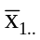= 15.5
 | 2 | 15, 15 | 22, 19 | 16, 17 | 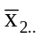= 17.33
 |  | 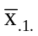 = 13.25 | 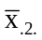 = 18.75 | 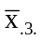= 17.25

The grand mean, 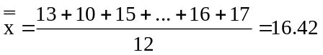

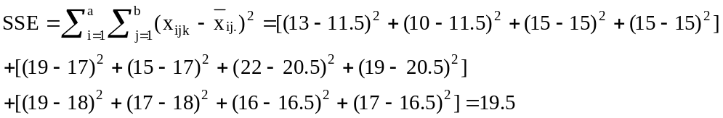
Note: 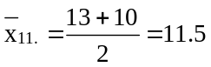
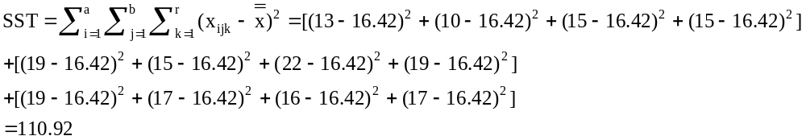

SSAB = SST - SSA - SSB - SSE = 110.92 - 10.05 - 64.67 - 19.5 = 16.70

A d.f. = a - 1 = 2 - 1 = 1
B d.f. = b - 1 = 3 - 1 = 2
AB d.f. = (a - 1)(b - 1) = 1(2) = 2
Error d.f. = ab(r - 1) = 2(3)(2 - 1) = 6
Total d.f. = abr - 1 = 2(3)(2) - 1 = 11

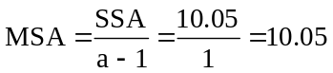, 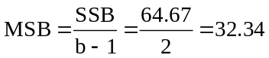, 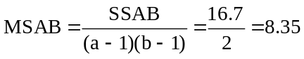
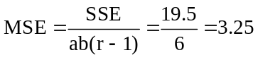
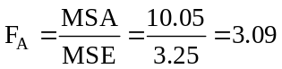, 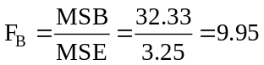, 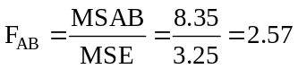

The ANOVA table is:
Variation Source | Sum of Squares | Degrees of Freedom | Mean Square | F
Factor A | 10.05 | 1 | 10.05 | 3.09
Factor B | 64.67 | 2 | 32.34 | 9.95
Interaction, AB | 16.70 | 2 | 8.35 | 2.57
Error | 19.50 | 6 | 3.25
Total | 110.92 | 11

Testing for Main Effects, Factor A.
H₀: α_{i} = 0 for each value of i, i = 1 through 2
H₁: α_{i} ≠ 0 for at least one value of i
The calculated test statistic is 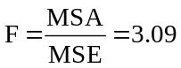
Using the F table, the critical value is F(0.05, 1, 6) = 5.99. The decision rule is: "Reject H₀ if the calculated F > 5.99, otherwise do not reject." Since the calculated test statistic falls in the nonrejection region, do not reject H₀. At the 0.05 level, we conclude that no level of Factor A has an effect.

Testing for Main Effects, Factor B.
H₀: β_{j} = 0 for each value of j, j = 1 through 3
H₁: β_{j} ≠ 0 for at least one value of j
The test statistic is 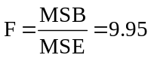
Using the F table, the critical value is F(0.05, 2, 6) = 5.14. The decision rule is: "Reject H₀ if the calculated F > 5.14, otherwise do not reject." Since the calculated test statistic falls in the rejection region, reject H₀. At the 0.05 level, we conclude that at least one level of Factor B has an effect.

Testing for Interaction Effects
H₀: (αβ)_{ij} = 0 for each combination of i and j
H₁: (αβ)_{ij} ≠ 0 for at least one combination of i and j
The test statistic is 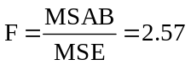
Using the F table, the critical value is F(0.05, 2, 6) = 5.14. The decision rule is: "Reject H₀ if the calculated F > 5.14, otherwise do not reject." Since the calculated test statistic falls in the nonrejection region, do not reject H₀. At the 0.05 level, we conclude that there is no relationship between the levels of Factor A and Factor B.

The Minitab printout is shown below. Some values differ slightly from those shown previously, due to rounding. Note the p-values shown in the Minitab printout: Factor A test, p-value = 0.129; Factor B test, p-value = 0.012, and Interaction AB test, p-value = 0.157.

Two-way ANOVA: value versus FactorA, FactorB
Analysis of Variance for value
Source DF SS MS F P
FactorA 1 10.08 10.08 3.10 0.129
FactorB 2 64.67 32.33 9.95 0.012
Interaction 2 16.67 8.33 2.56 0.157
Error 6 19.50 3.25
Total 11 110.92

Individual 95% CI
FactorA Mean ---------+---------+---------+---------+--
1 15.50 (-----------*-----------)
2 17.33 (-----------*-----------)
---------+---------+---------+---------+--
15.00 16.50 18.00 19.50

Individual 95% CI
FactorB Mean ------+---------+---------+---------+-----
1 13.25 (--------*--------)
2 18.75 (--------*--------)
3 17.25 (--------*--------)
------+---------+---------+---------+-----
12.50 15.00 17.50 20.00

The row and column means, along with the cell means, are shown below:

Tabulated Statistics: FactorA, FactorB
Rows: FactorA Columns: FactorB

1 2 3 All
1 11.500 17.000 18.000 15.500
2 15.000 20.500 16.500 17.333
All 13.250 18.750 17.250 16.417

Cell Contents --
value:Mean

The corresponding Excel printout is shown below. The p-values are: Factor A test, p-value = 0.129; Factor B test, p-value = 0.012, and Interaction AB test, p-value = 0.157.
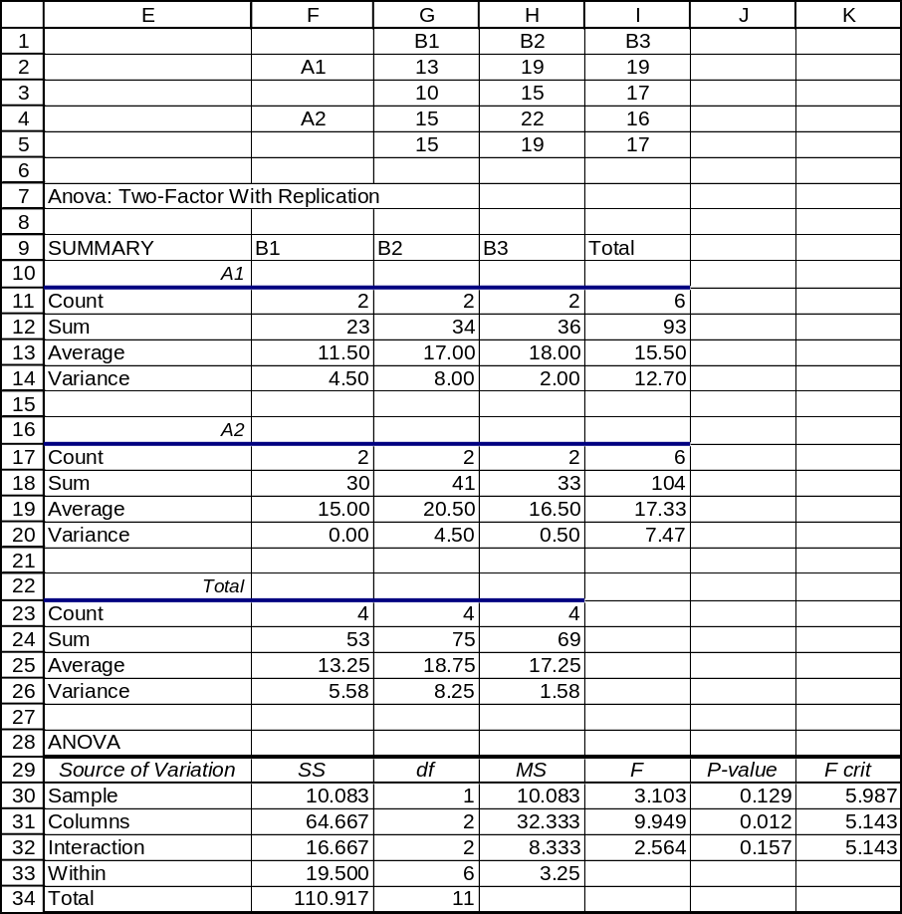

12.72 c/c/d The Excel printout for this problem is shown below. From it, we can determine the following summary findings:
Testing for Main Effects, Factor A.
H₀: α_{i} = 0 for each value of i, i = 1 through 3
H₁: α_{i} ≠ 0 for at least one value of i
The calculated test statistic is F = 8.494. The p-value for this test is 0.008, which is < α = 0.05.
Reject H₀. At the 0.05 level, at least one level of Factor A has an effect.

Testing for Main Effects, Factor B.
H₀: β_{j} = 0 for each value of j, j = 1 through 3
H₁: β_{j} ≠ 0 for at least one value of j
The calculated test statistic is F = 2.258. The p-value is 0.160, which is not < α = 0.05. Do not reject H₀. At the 0.05 level, we conclude that no level of Factor B has an effect.

Testing for Interaction Effects
H₀: (αβ)_{ij} = 0 for each combination of i and j
H₁: (αβ)_{ij} ≠ 0 for at least one combination of i and j
The calculated test statistic is F = 17.073. The p-value for this test, to three decimal places, is 0.000, which is < α = 0.05. Reject H₀. At the 0.05 level, there is some relationship between the levels of Factor A and Factor B.
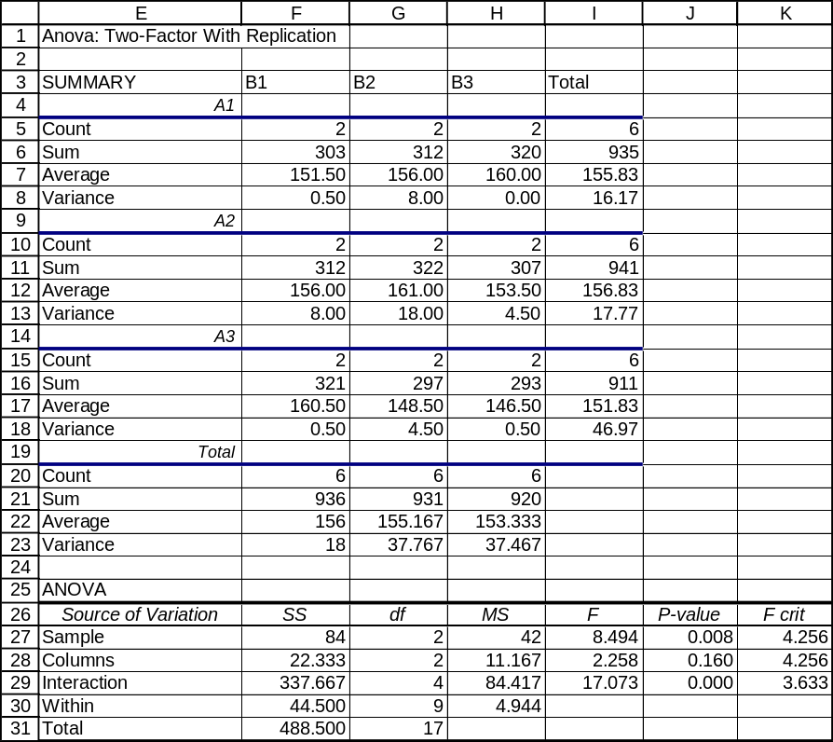

12.73 c/c/d The Minitab printout for this problem is shown below. The p-values are: Factor A test,
p-value = 0.000; Factor B test, p-value = 0.012, and Interaction AB test, p-value = 0.031.

Two-way ANOVA: value versus FactorA, FactorB
Analysis of Variance for value
Source DF SS MS F P
FactorA 2 227.06 113.53 13.58 0.000
FactorB 3 113.44 37.81 4.52 0.012
Interaction 6 142.06 23.68 2.83 0.031
Error 24 200.67 8.36
Total 35 683.22

Individual 95% CI
FactorA Mean ----+---------+---------+---------+-------
1 64.17 (------*------)
2 59.75 (------*------)
3 58.25 (------*------)
----+---------+---------+---------+-------
57.50 60.00 62.50 65.00

Individual 95% CI
FactorB Mean ---+---------+---------+---------+--------
1 61.33 (-------*-------)
2 58.78 (-------*-------)
3 59.44 (-------*-------)
4 63.33 (-------*-------)
---+---------+---------+---------+--------
57.50 60.00 62.50 65.00

The row and column means, along with the cell means, are shown below:

Tabulated Statistics: FactorA, FactorB
Rows: FactorA Columns: FactorB

1 2 3 4 All
1 61.000 63.333 63.667 68.667 64.167
2 60.667 57.667 60.333 60.333 59.750
3 62.333 55.333 54.333 61.000 58.250
All 61.333 58.778 59.444 63.333 60.722

Cell Contents --
value:Mean

Shown below are the data, along with a portion of the Excel printout for this problem. We will refer to this partial printout and its p-values in reaching conclusions for the three hypothesis tests.
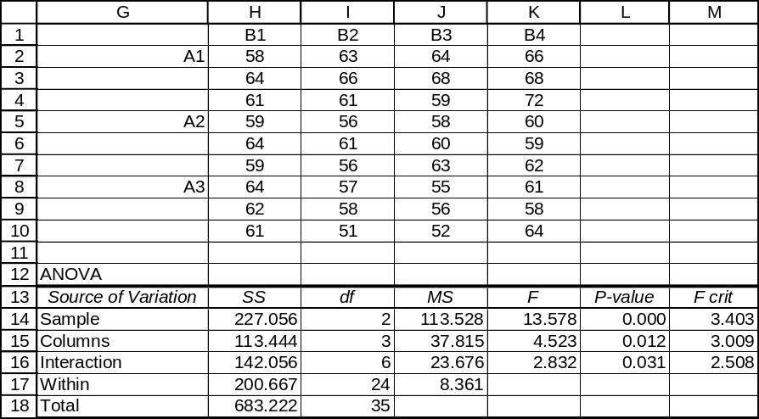

Testing for Main Effects, Factor A.
H₀: α_{i} = 0 for each value of i, i = 1 through 3
H₁: α_{i} ≠ 0 for at least one value of i
The calculated test statistic is F = 13.578. The p-value for this test, to three decimal places, is 0.000, which is < α = 0.05. Reject H₀. At the 0.05 level, at least one level of Factor A has an effect.

Testing for Main Effects, Factor B.
H₀: β_{j} = 0 for each value of j, j = 1 through 4
H₁: β_{j} ≠ 0 for at least one value of j
The calculated test statistic is F = 4.523. The p-value is 0.012, which is < α = 0.05. Reject H₀.
At the 0.05 level, at least one level of Factor B has an effect.

Testing for Interaction Effects
H₀: (αβ)_{ij} = 0 for each combination of i and j
H₁: (αβ)_{ij} ≠ 0 for at least one combination of i and j
The calculated test statistic is F = 2.832. The p-value for this test is 0.031, which is < α = 0.05.
Reject H₀. At the 0.05 level, there appears to be some relationship between the levels of Factor A and Factor B.

12.74 c/a/d
Factor A: d.f. = 11 - (1 + 2 + 6) = 2

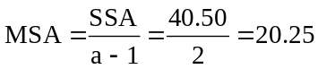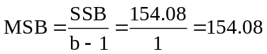

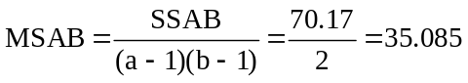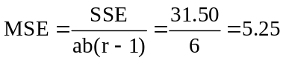

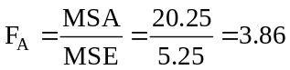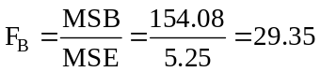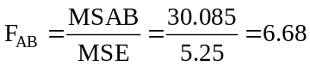

The completed ANOVA table is:
Variation Source | Sum of Squares | Degrees of Freedom | Mean Square | F
Factor A | 40.50 | 2 | 20.25 | 3.86
Factor B | 154.08 | 1 | 154.08 | 29.35
Interaction, AB | 70.17 | 2 | 35.085 | 6.68
Error | 31.50 | 6 | 5.25
Total | 296.25 | 11

Testing for Main Effects, Factor A.
H₀: α_{i} = 0 for each value of i, i = 1 through 3
H₁: α_{i} ≠ 0 for at least one value of i
The calculated test statistic is F = 3.86. Using the F table, the critical value is F(0.05, 2, 6) = 5.14.
The decision rule is: "Reject H₀ if the calculated F > 5.14, otherwise do not reject." Since the calculated test statistic falls in the nonrejection region, do not reject H₀. At the 0.05 level, we conclude that no level of Factor A has an effect.

Testing for Main Effects, Factor B.
H₀: β_{j} = 0 for each value of j, j = 1 through 2
H₁: β_{j} ≠ 0 for at least one value of j
The calculated test statistic is F = 29.35. Using the F table, the critical value is F(0.05, 1, 6) = 5.99. The decision rule is: "Reject H₀ if the calculated F > 5.99, otherwise do not reject." Since the calculated test statistic falls in the rejection region, reject H₀. At the 0.05 level, we conclude that at least one level of Factor B has an effect.

Testing for Interaction Effects
H₀: (αβ)_{ij} = 0 for each combination of i and j
H₁: (αβ)_{ij} ≠ 0 for at least one combination of i and j
The calculated test statistic is F = 6.68. Using the F table, the critical value is F(0.05, 2, 6) = 5.14.
The decision rule is: "Reject H₀ if the calculated F > 5.14, otherwise do not reject." Since the calculated test statistic falls in the rejection region, reject H₀. At the 0.05 level, we conclude that there is some relationship between the levels of Factor A and Factor B.

12.75 p/c/d Below is a partial Excel printout that includes the data for this problem:
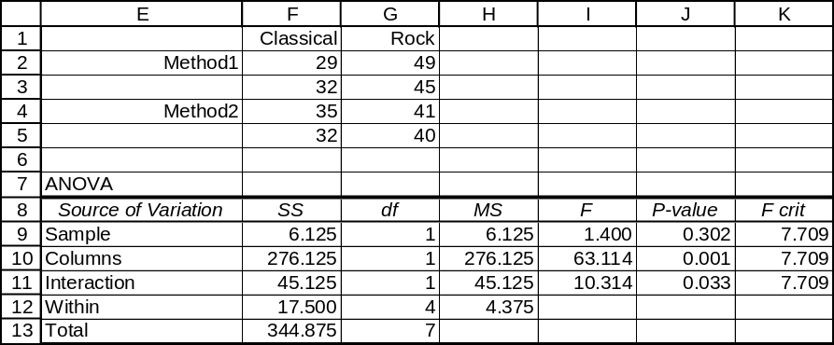
Testing for Main Effects, Factor A.
H₀: α_{i} = 0 for each value of i, i = 1 through 2
H₁: α_{i} ≠ 0 for at least one value of i
The calculated test statistic is F = 1.400. The p-value = 0.303 is not < α = 0.05. Do not reject H₀.
At the 0.05 level, none of the assembly methods has any effect on the number of boards assembled.

Testing for Main Effects, Factor B.
H₀: β_{j} = 0 for each value of j, j = 1 through 2
H₁: β_{j} ≠ 0 for at least one value of j
The calculated test statistic is F = 63.114. The p-value is 0.001, which is < α = 0.05. Reject H₀.
At the 0.05 level, at least one of the types of background music has an effect on the number of circuit boards assembled.

Testing for Interaction Effects
H₀: (αβ)_{ij} = 0 for each combination of i and j
H₁: (αβ)_{ij} ≠ 0 for at least one combination of i and j
The calculated test statistic is F = 10.314. The p-value for this test is 0.033, which is < α = 0.05. Reject H₀. At the 0.05 level, there appears to be some relationship between the assembly method used and the type of background music played.

The corresponding Minitab printout is shown below. It includes the confidence intervals that we are going to verify by use of our formulas. We will also use Minitab to generate the cell means:

Two-way ANOVA: boards versus method, music
Analysis of Variance for boards
Source DF SS MS F P
method 1 6.13 6.13 1.40 0.302
music 1 276.13 276.13 63.11 0.001
Interaction 1 45.13 45.13 10.31 0.033
Error 4 17.50 4.38
Total 7 344.88

Individual 95% CI
method Mean ----------+---------+---------+---------+-
1 38.8 (--------------*-------------)
2 37.0 (--------------*--------------)
----------+---------+---------+---------+-
36.0 38.0 40.0 42.0

Individual 95% CI
music Mean --+---------+---------+---------+---------
1 32.0 (-----*-----)
2 43.8 (-----*----)
--+---------+---------+---------+---------
30.0 35.0 40.0 45.0

Tabulated Statistics: method, music
Rows: method Columns: music

1 2 All
1 30.500 47.000 38.750
2 33.500 40.500 37.000
All 32.000 43.750 37.875

Cell Contents --
boards:Mean

For a confidence level of 95%, the right-tail area of interest is (1 - 0.95)/2 = 0.025 with d.f. = 4.
Referring to the t table, t = 2.776. Using the square root of the MSE for the population standard deviation (and the Excel printout's MSE = 4.375), this will be the square root of 4.375, or 2.092.
The 95% confidence interval for μ_{1A}, the population mean associated with level 1 of Factor A
(the assembly method -- assembly method 1) is:
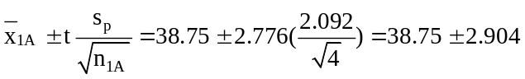 or from 35.846 to 41.654
The 95% confidence interval for μ_{2A}, the population mean associated with level 2 of Factor A
(the assembly method -- assembly method 2) is:
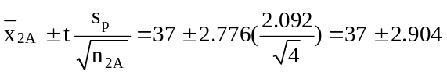 or from 34.096 to 39.904
The 95% confidence interval for μ_{1B}, the population mean associated with level 1 of Factor B
(the music played -- classical music) is:
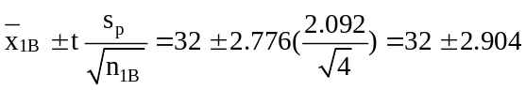 or from 29.096 to 34.904
The 95% confidence interval for μ_{2B}, the population mean associated with level 2 of Factor B
(the music played -- rock music) is:
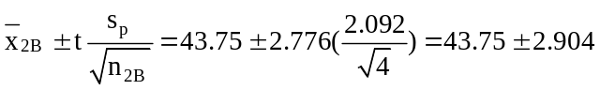 or from 40.846 to 46.654

12.76 p/a/m
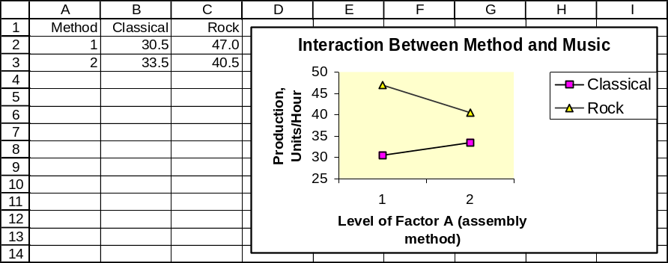

Since the lines are not parallel, there is some interaction present between the assembly method and the type of background music. The average number of units produced is greatest when assembly method 1 is used and rock music is played in the background.

12.77 p/c/d Shown below is the underlying data and a partial Excel printout for this problem situation:
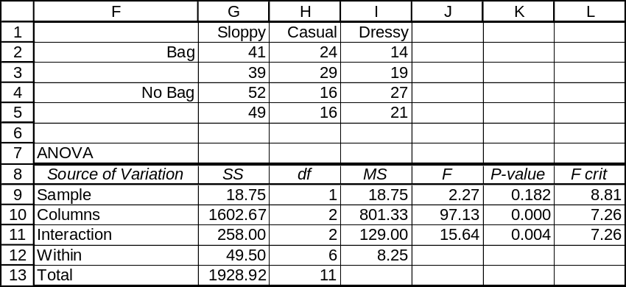
Testing for Main Effects, Factor A
H₀: α_{i} = 0 for each value of i, i = 1 through 2
H₁: α_{i} ≠ 0 for at least one value of i
The calculated test statistic is F = 2.27. The p-value is 0.182, which is not < α = 0.025. Do not reject H₀. At the 0.025 level, we conclude that carrying or not carrying a shopping bag has no effect on the number of seconds it takes to get waited on.

Testing for Main Effects, Factor B
H₀: β_{j} = 0 for each value of j, j = 1 through 3
H₁: β_{j} ≠ 0 for at least one value of j
The calculated test statistic is F = 97.13. The p-value is displayed as 0.000, and this is < α = 0.025. Reject H₀. At the 0.025 level, we conclude that at least one of the dress modes has an effect on the number of seconds it takes to get waited on.

Testing for Interaction Effects
H₀: (αβ)_{ij} = 0 for each combination of i and j
H₁: (αβ)_{ij} ≠ 0 for at least one combination of i and j
The calculated test statistic is F = 15.64. The p-value for this test is 0.004, which is < α = 0.025. Reject H₀. At the 0.025 level, there appears to be some relationship between whether a shopping bag is carried and mode of dress.

The corresponding Minitab printout is shown below. It includes the confidence intervals that we are
going to verify by use of our formulas. We will also use Minitab to generate the cell means:

Two-way ANOVA: time versus bag, dress
Analysis of Variance for time
Source DF SS MS F P
bag 1 18.75 18.75 2.27 0.182
dress 2 1602.67 801.33 97.13 0.000
Interaction 2 258.00 129.00 15.64 0.004
Error 6 49.50 8.25
Total 11 1928.92

Individual 95% CI
bag Mean -------+---------+---------+---------+----
1 27.7 (-------------*--------------)
2 30.2 (--------------*-------------)
-------+---------+---------+---------+----
26.0 28.0 30.0 32.0

Individual 95% CI
dress Mean ----------+---------+---------+---------+-
1 45.3 (----*---)
2 21.3 (----*---)
3 20.3 (---*----)
----------+---------+---------+---------+-
24.0 32.0 40.0 48.0

Using Minitab, the row, column, and cell means are as shown below:

Tabulated Statistics: bag, dress
Rows: bag Columns: dress

1 2 3 All
1 40.000 26.500 16.500 27.667
2 50.500 16.000 24.000 30.167
All 45.250 21.250 20.250 28.917

Cell Contents --
time:Mean

For a confidence level of 95%, the right-tail area of interest is (1 - 0.95)/2 = 0.025 with d.f. = 6.
Referring to the t table, t = 2.447. Using the square root of the MSE for the population standard deviation, our estimate of the population standard deviation is the square root of 8.25, or 2.872 minutes.

The 95% confidence interval for μ_{1A}, the population mean associated with level 1 of Factor A
(shopping bag -- a bag is carried) is:
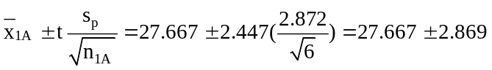 or from 24.798 to 30.536
The 95% confidence interval for μ_{2A}, the population mean associated with level 2 of Factor A
(shopping bag -- a bag is not carried) is:
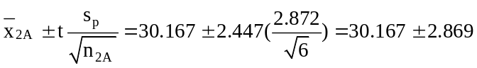 or from 27.298 to 33.036

The 95% confidence interval for μ_{1B}, the population mean associated with level 1 of Factor B
(mode of dress -- sloppy) is:
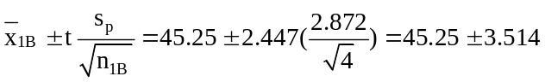 or from 41.736 to 48.764

The 95% confidence interval for μ_{2B}, the population mean associated with level 2 of Factor B
(mode of dress -- casual) is:
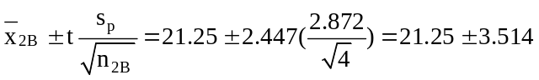 or from 17.736 to 24.764
The 95% confidence interval for μ_{3B}, the population mean associated with level 3 of Factor B
(mode of dress -- dressy) is:
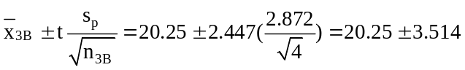 or from 16.736 to 23.764

12.78 p/a/m
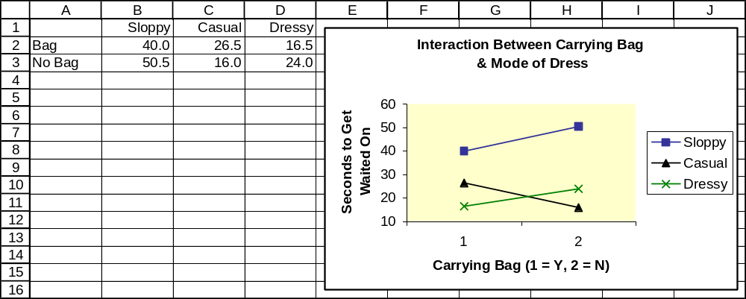

Since the lines are not parallel, there is some interaction between whether a shopping bag is carried and the mode of dress. For example, note that the “Casual” and “Dressy” lines cross. For persons in casual dress, carrying a bag will tend to increase the time it takes to get waited on, but the reverse will tend to occur for persons who are dressed up and carrying a bag.

12.79 p/a/d
Testing for Main Effects, Factor A
H₀: α_{i} = 0 for each value of i, i = 1 through 3
H₁: α_{i} ≠ 0 for at least one value of i
Because p-value = 0.043 is less than the 0.05 level of significance being used to reach a conclusion,
we reject H₀. At the 0.05 level, we conclude that at least one level of keyboard configuration has an effect on the number of minutes required to type a document.

Testing for Main Effects, Factor B
H₀: β_{j} = 0 for each value of j, j = 1 through 2
H₁: β_{j} ≠ 0 for at least one value of j
Because p-value = 0.104 is not less than the 0.05 level of significance being used to reach a conclusion, we do not reject H₀. At the 0.05 level, we conclude that none of the word processing packages has any effect on the number of minutes required to type a document.

Testing for Interaction Effects
H₀: (αβ)_{ij} = 0 for each combination of i and j
H₁: (αβ)_{ij} ≠ 0 for at least one combination of i and j
Because p-value = 0.021 is less than the 0.05 level of significance being used to reach a conclusion,
we reject H₀. At the 0.05 level, we conclude that there is some relationship between the keyboard configuration and the word processing package.

12.80 c/a/d
For a confidence level of 95%, the right-tail area of interest is (1 - 0.95)/2 = 0.025 with d.f. = 6. Referring to the t table, t = 2.447. Using the square root of the MSE (0.0583) as the population standard deviation (0.241):
The 95% confidence interval for μ_{1A}, the population mean associated with level 1 of Factor A
(keyboard configuration) is:
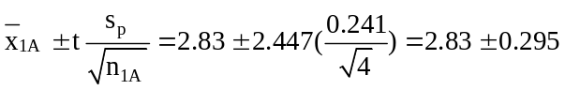 or 2.535 to 3.125
The 95% confidence interval for μ_{2A}, the population mean associated with level 2 of Factor A
(keyboard configuration) is:
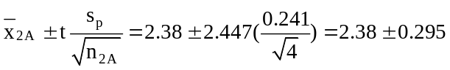 or from 2.085 to 2.675
The 95% confidence interval for μ_{3A}, the population mean associated with level 3 of Factor A
(keyboard configuration) is:
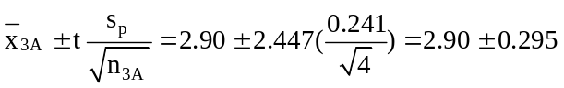 or from 2.605 to 3.195

The 95% confidence interval for μ_{1B}, the population mean associated with level 1 of Factor B
(word processing package) is:
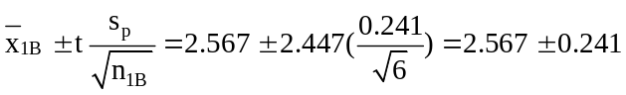 or from 2.326 to 2.808
The 95% confidence interval for μ_{2B}, the population mean associated with level 2 of Factor B
(word processing package) is:
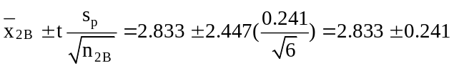 or from 2.592 to 3.074

CHAPTER EXERCISES
12.81 d/p/m When we are interested in the effects of one factor on the dependent variable and the treatments are randomly assigned to all of the test units in the experiment, we would use one-way analysis of variance. If all of the test units are similar, this would be the analysis to use. If we are interested in the effects of one factor on the dependent variable but the test units can be arranged into similar groups, or "blocks" before the treatments are assigned, we would use the randomized block design. This allows us to reduce the amount of "error" variation. If we are interested in the effects of two different factors on the dependent variable, then two-way analysis of variance would be used. Then we can look at the effects of both factors simultaneously and also test for any interaction between them.

12.82 d/p/m The t-tests of chapter 11 and the ANOVA techniques can be used interchangeably if there are only two treatments to be compared. However, if there are more than two treatments, the t-tests in chapter 11 cannot be applied.

12.83 d/p/m The randomized block design has not been used in this analysis. In the randomized block design, the confidence interval for a treatment mean would not be meaningful. The treatments are applied randomly only within a block.

12.84 d/p/m
a. Since we are interested in how the longevity influences the number of shares of stock held, the independent variable is the number of years the employee has been with the firm and the dependent variable is the number of shares of stock the employee holds. This is not a "designed" experiment since we cannot randomly assign the employees to the longevity groups.
b. The independent variable must be converted from a quantitative form to a qualitative form. This can be done by grouping the years into categories representing low, medium, and high longevity.
For example, 0-9 years could be low, 10-20 could be medium, and over 20 could be high.

12.85 d/c/m The independent variable is faceplate design and the dependent variable is time to complete the assigned task. This is a designed experiment.

12.86 d/c/m One-way ANOVA. The nine drivers have been randomly assigned to the three groups.

12.87 d/c/m No. The randomized block ANOVA procedure would now be appropriate. We are not really interested in the effect of the age variable, we are only interested in using it as a blocking variable.
This study would be similar to the headlamp-design example in the randomized block section of the chapter.

12.88 p/c/m The one-way ANOVA procedure is used and the Minitab results are shown below.
The p-value (0.438) is not less than the 0.025 level of significance used in reaching a conclusion, so we do not reject H₀. At the 0.025 level, the three preparation courses could be equally effective.

One-way ANOVA: prepA, prepB, current
Analysis of Variance
Source DF SS MS F P
Factor 2 118.9 59.5 0.88 0.438
Error 12 806.4 67.2
Total 14 925.3
Individual 95% CIs For Mean
Based on Pooled StDev
Level N Mean StDev --------+---------+---------+--------
prepA 5 72.400 9.236 (----------*-----------)
prepB 5 65.600 8.473 (-----------*----------)
current 5 70.000 6.671 (----------*----------)
--------+---------+---------+--------
Pooled StDev = 8.198 63.0 70.0 77.0

12.89 p/c/m The Minitab and Excel printouts are shown below. The Excel printout includes the data.

One-way ANOVA: present1, present2, present3
Analysis of Variance
Source DF SS MS F P
Factor 2 46.61 23.31 7.00 0.011
Error 11 36.60 3.33
Total 13 83.21
Individual 95% CIs For Mean
Based on Pooled StDev
Level N Mean StDev -----+---------+---------+---------+-
present1 4 8.500 1.915 (-------*-------)
present2 5 12.200 1.643 (------*------)
present3 5 12.800 1.924 (------*------)
-----+---------+---------+---------+-
Pooled StDev = 1.824 7.5 10.0 12.5 15.0
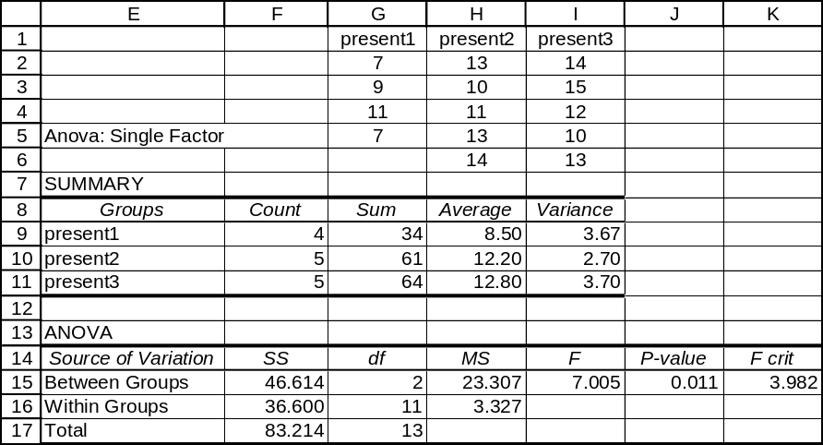

The null and alternative hypotheses are: H₀: μ₁ = μ₂ = μ₃ and H₁: the population means are not equal.
The calculated test statistic is F = 7.005. The p-value for this test is 0.011, which is < α = 0.05. Reject H₀. At the 0.05 level, we conclude that the three sales presentations are not equally effective.

12.90 p/c/m The Minitab and Excel printouts are shown below:

One-way ANOVA: brand1, brand2, brand3, brand4
Analysis of Variance
Source DF SS MS F P
Factor 3 209.6 69.9 5.86 0.020
Error 8 95.3 11.9
Total 11 304.9
Individual 95% CIs For Mean
Based on Pooled StDev
Level N Mean StDev ---+---------+---------+---------+---
brand1 3 20.000 3.000 (------*-------)
brand2 3 15.333 4.041 (-------*------)
brand3 3 26.000 3.606 (------*-------)
brand4 3 16.333 3.055 (------*-------)
---+---------+---------+---------+---
Pooled StDev = 3.452 12.0 18.0 24.0 30.0

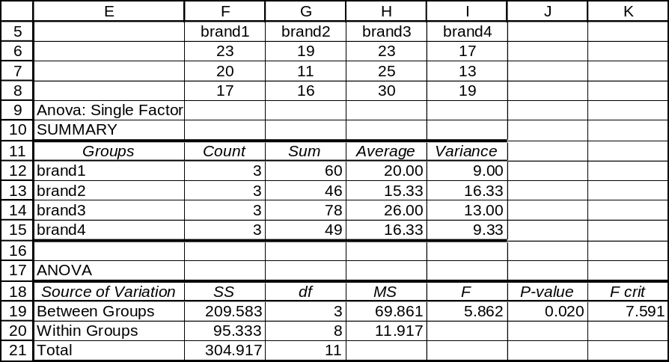

a. The estimated value of the common variance, σ², that is assumed to be shared by the four populations from the variation between the samples is given by the MSTR. To three decimal places, MSTR is 69.861.
b. The estimated value of the common variance, σ², that is assumed to be shared by the four populations from the variation within the samples is given by the MSE. To three decimal places, MSE = 11.917.
c. The null and alternative hypotheses are: H₀: μ₁ = μ₂ = μ₃ = μ₄ and H₁: the population means are not equal. To three decimal places, the calculated test statistic is F = 5.862. The p-value for this test is 0.020, which is not < α = 0.01. At the 0.01 level, we conclude that the four types of brake linings are equally durable.

12.91 p/c/m For this problem, the four assessors are the treatments and the five homes are the blocks.
The Minitab printout and a portion of the Excel printout are shown below:

Two-way ANOVA: amount versus home, assessor
Analysis of Variance for amount
Source DF SS MS F P
home 4 6638.3 1659.6 38.20 0.000
assessor 3 461.2 153.7 3.54 0.048
Error 12 521.3 43.4
Total 19 7620.8

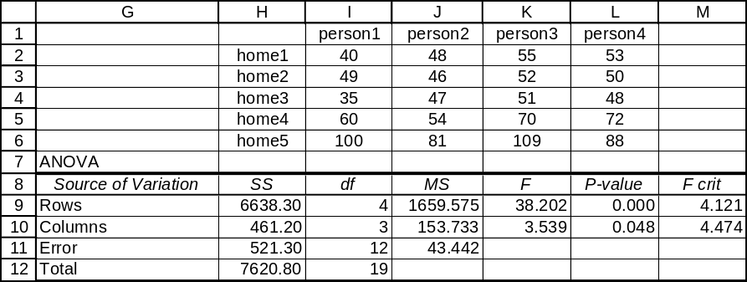

Testing for treatment effects:
To determine if the treatment (assessor) effects could all be zero, we test:
H₀: τ_{j} = 0 for treatments j = 1, 2, 3, 4 and H₁: τ_{j} ≠ 0 for at least one of the treatments
Referring to the Excel printout, the calculated test statistic is: 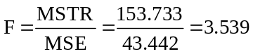
and the p-value for the test of treatment (assessor) effects is 0.048. The p-value = 0.048 is not less than the α = 0.025 level of significance being used in the test, so we do not reject H₀. At the 0.025 level, we conclude that the assessments provided by the four assessors are equal. As might be expected, the p-value for the test of the block (homes) effect is much stronger. To three decimal places, the p-value = 0.000.

12.92 p/c/m The Minitab printout is shown below:

One-way ANOVA: sample1, sample2, sample3
Analysis of Variance
Source DF SS MS F P
Factor 2 195.6 97.8 3.81 0.048
Error 14 359.5 25.7
Total 16 555.1
Individual 95% CIs For Mean
Based on Pooled StDev
Level N Mean StDev -------+---------+---------+---------
sample1 6 11.333 4.082 (--------*--------)
sample2 6 15.333 5.820 (--------*--------)
sample3 5 19.800 5.167 (---------*--------)
-------+---------+---------+---------
Pooled StDev = 5.067 10.0 15.0 20.0

The calculated test statistic is F = 3.81 and the p-value is 0.048, which is not < α = 0.025, the level of significance at which the test is being conducted. At the 0.025 level, we do not reject H₀: μ₁ = μ₂ = μ₃.
At this level, the treatments are equally effective.

12.93 p/c/m We wish to determine if the three brands of bathroom scales could have the same population mean for this test object, so the null and alternative hypotheses are H₀: μ₁ = μ₂ = μ₃ and H₁: the population means are not equal. Applying one-way analysis of variance, we obtain the Minitab and Excel printouts below:

One-way ANOVA: BrandA, BrandB, BrandC
Analysis of Variance
Source DF SS MS F P
Factor 2 126.72 63.36 8.52 0.005
Error 12 89.28 7.44
Total 14 216.00
Individual 95% CIs For Mean
Based on Pooled StDev
Level N Mean StDev --------+---------+---------+--------
BrandA 5 202.40 3.21 (------*-------)
BrandB 4 199.75 2.99 (--------*-------)
BrandC 6 195.67 2.07 (------*------)
--------+---------+---------+--------
Pooled StDev = 2.73 196.0 199.5 203.0

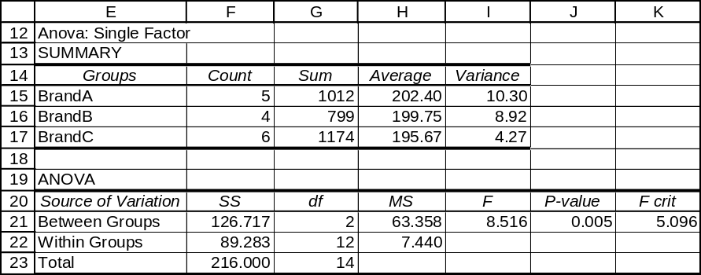

Since p-value = 0.005 is < α = 0.025, the level of significance for the test, we reject H₀. At the 0.025 level, we conclude that the three brands of bathroom scales do not have the same population mean for this test object.

12.94 p/c/d We wish to determine if the four alloy compositions could have the same population mean, so the null and alternative hypotheses are H₀: μ₁ = μ₂ = μ₃ = μ₄ and H₁: the population means are not equal. Applying one-way analysis of variance, we obtain the Minitab and Excel printouts below:

One-way ANOVA: Comp1, Comp2, Comp3, Comp4
Analysis of Variance
Source DF SS MS F P
Factor 3 243.0 81.0 3.22 0.065
Error 11 276.6 25.1
Total 14 519.6
Individual 95% CIs For Mean
Based on Pooled StDev
Level N Mean StDev --------+---------+---------+--------
Comp1 3 46.333 4.509 (---------*----------)
Comp2 4 50.250 3.862 (--------*--------)
Comp3 3 44.000 4.583 (---------*----------)
Comp4 5 54.400 6.107 (--------*-------)
--------+---------+---------+--------
Pooled StDev = 5.015 42.0 48.0 54.0

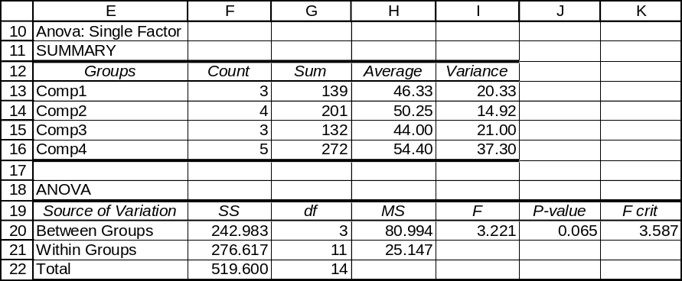

Since p-value = 0.065 is not < α = 0.05, the level of significance for the test, we do not reject H₀. At the 0.05 level, we conclude that the four alloy compositions could have the same population mean hardness. The 95% confidence interval for each factor level mean (shown in the Minitab printout) can be computed from the Excel printout as shown below:

For a confidence level of 95%, the right-tail area of interest is (1 - 0.95)/2 = 0.025 with d.f. = 11. Referring to the t table, t = 2.201. MSE = 25.147, and its square root (5.015) is the pooled estimate for the population standard deviation.
The 95% confidence interval for μ₁ is:
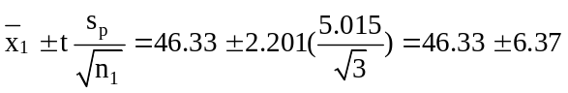 or from 39.96 to 52.70
The 95% confidence interval for μ₂ is:
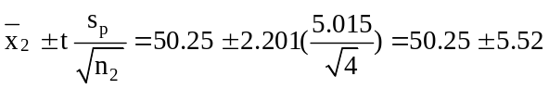 or from 44.73 to 55.77
The 95% confidence interval for μ₃ is:
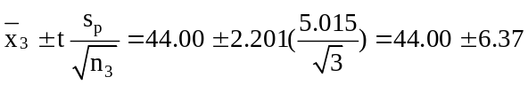 or from 37.63 to 50.37
The 95% confidence interval for μ₄ is:
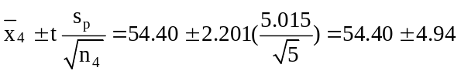 or from 49.46 to 59.34

12.95 p/c/m For this problem, the three portfolios are the treatments and the four advisors are the blocks. The Minitab printout is shown below:

Two-way ANOVA: estrate versus advisor, portfol
Analysis of Variance for estrate
Source DF SS MS F P
advisor 3 48.33 16.11 5.98 0.031
portfol 2 11.17 5.58 2.07 0.207
Error 6 16.17 2.69
Total 11 75.67

Since p-value = 0.207 is not less than α = 0.05, the level of significance for the test, we do not reject H₀. At the 0.05 level, we conclude that the three portfolios could be equal in terms of their estimated annual return.

12.96 p/c/m We wish to determine if the four brands of rope could have the same population mean breaking strength, so the null and alternative hypotheses are H₀: μ₁ = μ₂ = μ₃ = μ₄ and H₁: the population means are not equal. Applying one-way analysis of variance, we obtain the Minitab printout shown below:

One-way ANOVA: brandA, brandB, brandC, brandD
Analysis of Variance
Source DF SS MS F P
Factor 3 116.6 38.9 3.34 0.040
Error 20 232.5 11.6
Total 23 349.1
Individual 95% CIs For Mean
Based on Pooled StDev
Level N Mean StDev ------+---------+---------+---------+
brandA 6 109.47 4.19 (--------*-------)
brandB 6 114.05 3.97 (-------*-------)
brandC 6 111.13 2.44 (--------*-------)
brandD 6 114.95 2.70 (-------*--------)
------+---------+---------+---------+
Pooled StDev = 3.41 108.5 112.0 115.5 119.0

The calculated test statistic is F = 3.34 and the p-value is 0.040, which is not < α = 0.025, the level of significance at which the test is being conducted. At the 0.025 level, we do not reject H₀. At this level,
we conclude that the four brands of rope are equally strong.

12.97 p/c/m For this problem, the three publicity methods are the treatments and the three community sizes are the blocks. Minitab and Excel printouts are shown below:

Two-way ANOVA: Values versus CommSize, PubMeth
Analysis of Variance for Values
Source DF SS MS F P
CommSize 2 178.67 89.33 33.50 0.003
PubMeth 2 68.67 34.33 12.87 0.018
Error 4 10.67 2.67
Total 8 258.00

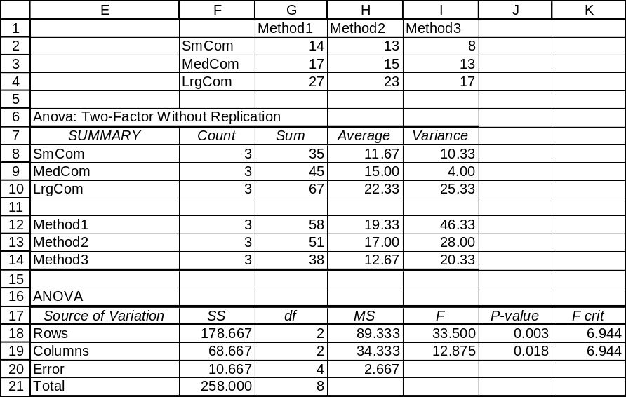

Testing for treatment effects:
To determine if the treatment (publicity method) effects could all be zero, we test:
H₀: τ_{j} = 0 for treatments j = 1, 2, 3 and H₁: τ_{j} ≠ 0 for at least one of the treatments
Referring to the Excel printout, the calculated test statistic is: 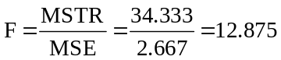and the
p-value for the treatment (publicity method) effects is 0.018. Since p-value = 0.018 is < α = 0.05,
the level of significance being used in the test, we reject H₀. At the 0.05 level, we conclude that the three publicity methods are not equally effective. The p-value for the test of the block (community size) effects is even lower: 0.003.

12.98 p/c/m For this problem, the four driving strategies are the treatments and the five drivers are the blocks. H₀: τ_{j} = 0 for treatments (strategies) j = 1, 2, 3, 4 and H₁: τ_{j} ≠ 0 for at least one of the treatments. The data and a portion of the Excel printout are shown below:
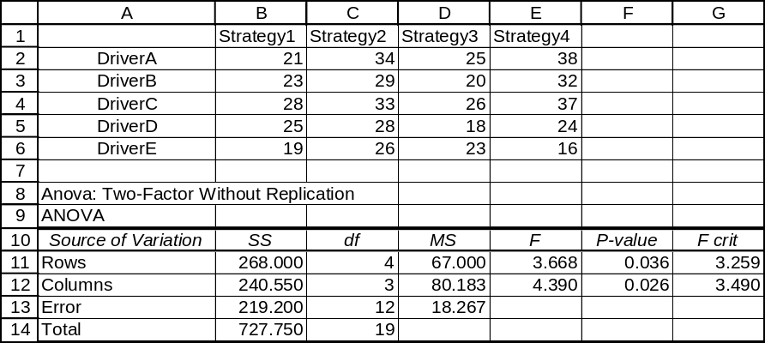

Since p-value = 0.026 is < α = 0.05, the level of significance for the test, we reject H₀. At the 0.05 level, we conclude that the four driving strategies are not equally effective.

12.99 p/c/d There are two factors: A (type style) and B (type darkness). We will apply two-way analysis of variance with two observations per cell. The Minitab printout is shown below. Factor means and confidence intervals for factor levels are included.

Two-way ANOVA: Seconds versus Style, Darkness
Analysis of Variance for Seconds
Source DF SS MS F P
Style 1 12.00 12.00 2.25 0.184
Darkness 2 64.50 32.25 6.05 0.036
Interaction 2 9.50 4.75 0.89 0.458
Error 6 32.00 5.33
Total 11 118.00

Individual 95% CI
Style Mean --+---------+---------+---------+---------
1 28.00 (-------------*-------------)
2 26.00 (-------------*--------------)
--+---------+---------+---------+---------
24.00 25.60 27.20 28.80

Individual 95% CI
Darkness Mean -------+---------+---------+---------+----
1 30.3 (---------*--------)
2 25.0 (--------*---------)
3 25.8 (---------*--------)
-------+---------+---------+---------+----
24.0 27.0 30.0 33.0

Using Minitab, we can also generate the cell means along with the factor level means:

Tabulated Statistics: Style, Darkness
Rows: Style Columns: Darkness

1 2 3 All
1 30.500 25.500 28.000 28.000
2 30.000 24.500 23.500 26.000
All 30.250 25.000 25.750 27.000

Cell Contents --
Seconds:Mean

The data setup and a portion of the Excel printout are shown below:
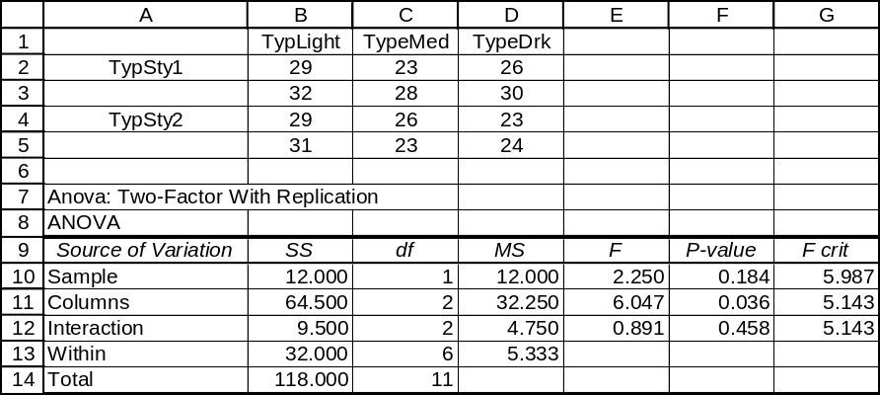

Testing for Main Effects, Factor A (type style):
H₀: α_{i} = 0 for each value of i, i = 1 through 2
H₁: α_{i} ≠ 0 for at least one value of i
The calculated test statistic is F = 2.250. The p-value is 0.184, which is not < α = 0.05.
Do not reject H₀. At the 0.05 level, none of the type styles has any effect on readability.

Testing for Main Effects, Factor B (type darkness)
H₀: β_{j} = 0 for each value of j, j = 1 through 3
H₁: β_{j} ≠ 0 for at least one value of j
The calculated test statistic is F = 6.047. The p-value is 0.036, which is < α = 0.05. Reject H₀.
At the 0.05 level, at least one of the levels of type darkness has an effect on readability.

Testing for Interaction Effects
H₀: (αβ)_{ij} = 0 for each combination of i and j
H₁: (αβ)_{ij} ≠ 0 for at least one combination of i and j
The calculated test statistic is F = 0.891. The p-value for this test is 0.458, which is not < α = 0.05.
Do not reject H₀. At the 0.05 level, there is no relationship between type style and type darkness.

For a confidence level of 95%, the right-tail area of interest is (1 - 0.95)/2 = 0.025 with d.f. = 6.
Referring to the t table, t = 2.447. MSE = 5.333, and its square root (2.309) is the estimate for the population standard deviation. The 95% confidence interval for each factor level mean (shown in the Minitab printout) can be computed from the Excel printout as shown below:

The 95% confidence interval for μ_{1A}, the population mean associated with level 1 of Factor A
(type style) is:
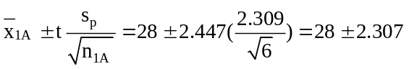 or from 25.693 to 30.307
The 95% confidence interval for μ_{2A}, the population mean associated with level 2 of Factor A
(type style) is:
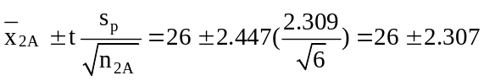 or from 23.693 to 28.307

The 95% confidence interval for μ_{1B}, the population mean associated with level 1 of Factor B
(type darkness) is:
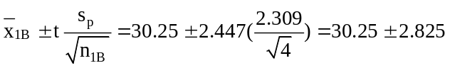 or from 27.425 to 33.075
The 95% confidence interval for μ_{2B}, the population mean associated with level 2 of Factor B
(type darkness) is:
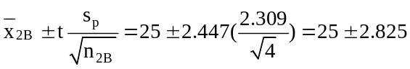 or from 22.175 to 27.825
The 95% confidence interval for μ_{3B}, the population mean associated with level 3 of Factor B
(type darkness) is:
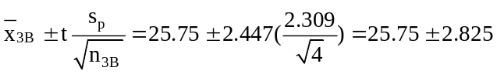 or from 22.925 to 28.575

12.100 p/c/d There are two factors: A (heat treatment method) and B (zinc-coating technique). We will apply two-way analysis of variance with two observations per cell. Minitab and Excel printouts are shown below:

Two-way ANOVA: pounds versus Heat, Coat
Analysis of Variance for pounds
Source DF SS MS F P
Heat 2 5251 2626 5.65 0.019
Coat 3 3234 1078 2.32 0.127
Interaction 6 27319 4553 9.80 0.000
Error 12 5574 465
Total 23 41378

Individual 95% CI
Heat Mean ---+---------+---------+---------+--------
1 716.0 (----------*---------)
2 721.1 (----------*---------)
3 749.6 (----------*---------)
---+---------+---------+---------+--------
704.0 720.0 736.0 752.0

Individual 95% CI
Coat Mean ---+---------+---------+---------+--------
1 727.0 (---------*--------)
2 729.0 (---------*--------)
3 713.5 (---------*--------)
4 746.2 (---------*---------)
---+---------+---------+---------+--------
700.0 720.0 740.0 760.0

The Excel data setup and printout:
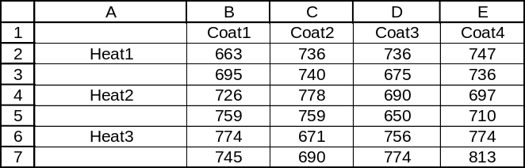

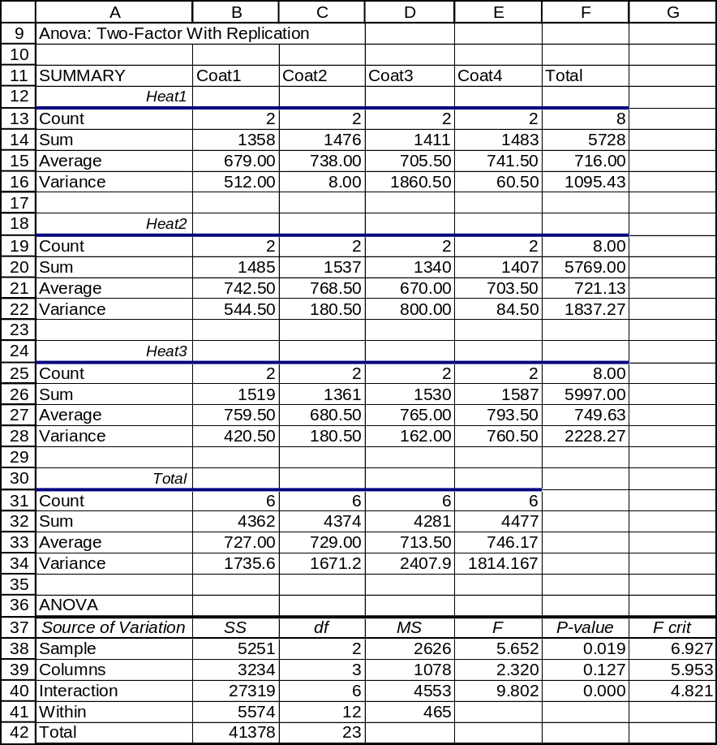

Testing for Main Effects, Factor A (heat treatment method):
H₀: α_{i} = 0 for each value of i, i = 1 through 3
H₁: α_{i} ≠ 0 for at least one value of i
The calculated test statistic is F = 5.652. The p-value is 0.019, which is not < α = 0.01.
Do not reject H₀. At the 0.01 level, we conclude that the three heat treatments are equally effective.

Testing for Main Effects, Factor B (zinc coating technique)
H₀: β_{j} = 0 for each value of j, j = 1 through 4
H₁: β_{j} ≠ 0 for at least one value of j
The calculated test statistic is F = 2.320. The p-value is 0.127, which is not < α = 0.01.
Do not reject H₀. At the 0.01 level, we conclude that the four zinc coating techniques are equally effective.

Testing for Interaction Effects
H₀: (αβ)_{ij} = 0 for each combination of i and j
H₁: (αβ)_{ij} ≠ 0 for at least one combination of i and j
The calculated test statistic is F = 9.802. The p-value for this test is 0.000, which is < α = 0.01.
Reject H₀. At the 0.01 level, we conclude that there is some relationship between the heat treatment
method and the zinc coating technique.

For a confidence level of 95%, the right-tail area of interest is (1 - 0.95)/2 = 0.025 with d.f. = 12. Referring to the t table, t = 2.179. MSE = 465, and its square root (21.564) is the estimate for the population standard deviation. The 95% confidence interval for each factor level mean (shown in the Minitab printout) can be computed from the Excel printout as shown below:

The 95% confidence interval for μ_{1A}, the population mean associated with level 1 of Factor A
(heat treatment method) is:
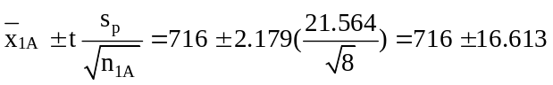 or from 699.387 to 732.613
The 95% confidence interval for μ_{2A}, the population mean associated with level 2 of Factor A
(heat treatment method) is:
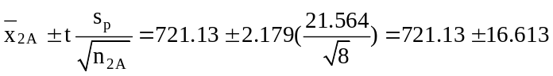 or from 704.517 to 737.743
The 95% confidence interval for μ_{3A}, the population mean associated with level 3 of Factor A
(heat treatment method) is:
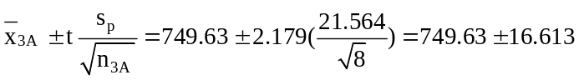 or from 733.017 to 766.243

The 95% confidence interval for μ_{1B}, the population mean associated with level 1 of Factor B
(zinc coating technique) is:
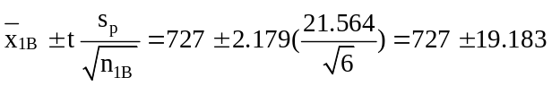 or from 707.817 to 746.183
The 95% confidence interval for μ_{2B}, the population mean associated with level 2 of Factor B
(zinc coating technique) is:
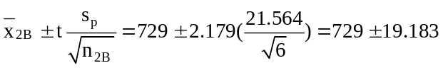 or from 709.817 to 748.183
The 95% confidence interval for μ_{3B}, the population mean associated with level 3 of Factor B
(zinc coating technique) is:
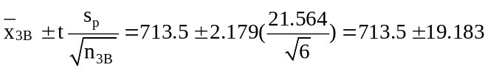 or from 694.317 to 732.683
The 95% confidence interval for μ_{4B}, the population mean associated with level 4 of Factor B
(zinc coating technique) is:
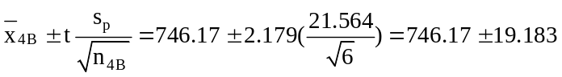 or 726.987 to 765.353

12.101 p/c/d There are two factors: A (position of the display) and B (type of display). Applying two-way analysis of variance with three observations per cell, Minitab and Excel printouts are shown below:

Two-way ANOVA: Tickets versus Position, Display
Analysis of Variance for Tickets
Source DF SS MS F P
Position 1 88.9 88.9 6.67 0.024
Display 2 71.4 35.7 2.68 0.109
Interaction 2 510.1 255.1 19.13 0.000
Error 12 160.0 13.3
Total 17 830.4

Individual 95% CI
Position Mean ----------+---------+---------+---------+-
1 45.3 (---------*----------)
2 49.8 (---------*----------)
----------+---------+---------+---------+-
45.0 47.5 50.0 52.5

Individual 95% CI
Display Mean ----------+---------+---------+---------+-
1 45.3 (----------*----------)
2 47.2 (----------*----------)
3 50.2 (----------*----------)
----------+---------+---------+---------+-
45.0 48.0 51.0 54.0

The Excel data setup and printout:
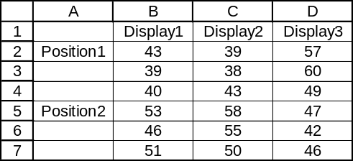

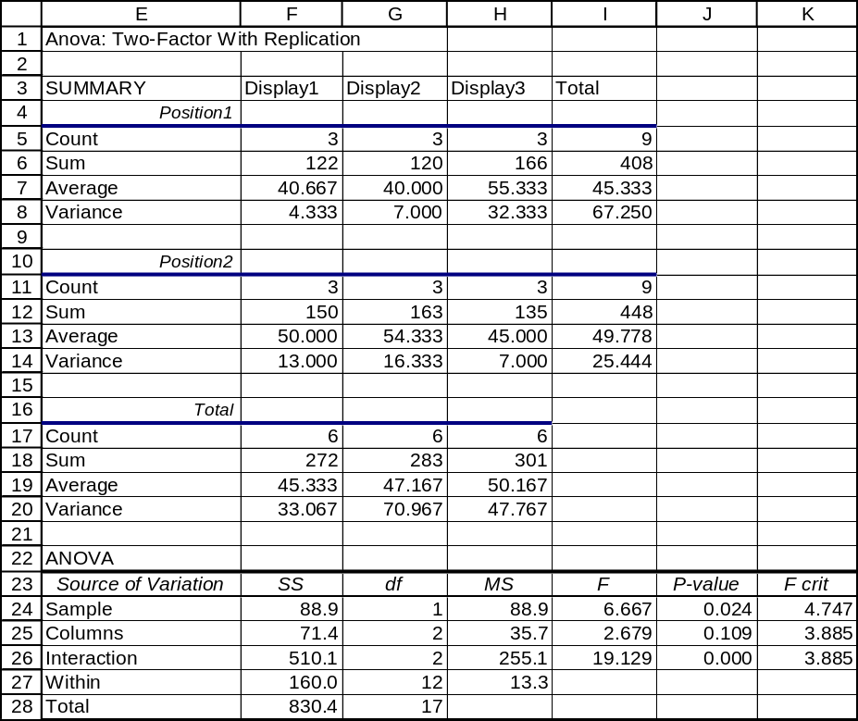
Testing for Main Effects, Factor A (position of display)
H₀: α_{i} = 0 for each value of i, i = 1 through 2
H₁: α_{i} ≠ 0 for at least one value of i
The calculated test statistic is F = 6.667. The p-value is 0.024, which is < α = 0.025. Reject H₀.
At the 0.025 level, we conclude that the two display positions are not equally effective.

Testing for Main Effects, Factor B (type of display)
H₀: β_{j} = 0 for each value of j, j = 1 through 3
H₁: β_{j} ≠ 0 for at least one value of j
The calculated test statistic is F = 2.679. The p-value is 0.109, which is not < α = 0.025.
Do not reject H₀. At the 0.025 level, we conclude that the three display positions are equally effective.

Testing for Interaction Effects
H₀: (αβ)_{ij} = 0 for each combination of i and j
H₁: (αβ)_{ij} ≠ 0 for at least one combination of i and j
The calculated test statistic is F = 19.129. The p-value for this test is 0.000, which is < α = 0.025. Reject H₀. At the 0.025 level, we conclude that there is some relationship between the position of the display and the type of display.

For a confidence level of 95%, the right-tail area of interest is (1 - 0.95)/2 = 0.025 with d.f. = 12. Referring to the t table, t = 2.179. MSE = 13.3, and its square root (3.647) is the estimate for the population standard deviation. The 95% confidence interval for each factor level mean (shown in the Minitab printout) can be computed from the Excel printout as shown below:

The 95% confidence interval for μ_{1A}, the population mean associated with level 1 of Factor A
(display position) is:
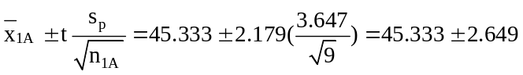 or from 42.684 to 47.982
The 95% confidence interval for μ_{2A}, the population mean associated with level 2 of Factor A
(display position) is:
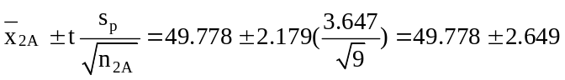 or from 47.129 to 52.427

The 95% confidence interval for μ_{1B}, the population mean associated with level 1 of Factor B
(type of display) is:
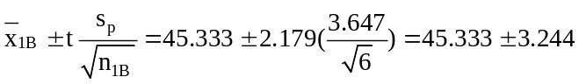 or from 42.089 to 48.577
The 95% confidence interval for μ_{2B}, the population mean associated with level 2 of Factor B
(type of display) is:
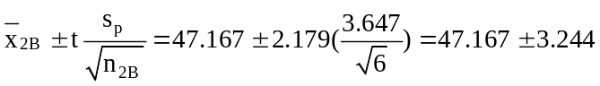 or from 43.923 to 50.411
The 95% confidence interval for μ_{3B}, the population mean associated with level 3 of Factor B
(type of display) is:
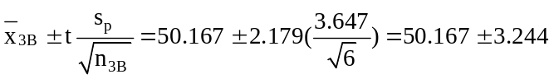 or from 46.923 to 53.411
INTEGRATED CASES

THORNDIKE SPORTS EQUIPMENT (THORNDIKE VIDEO UNIT SIX)
In order to help Ted determine the best combination of power racquet and string for Kermit, a two-way analysis of variance should be done. The factors will be A (type of string) and B (type of power racquet) and we will carry out our tests at the 0.05 level of significance. Minitab and Excel printouts are below:

Two-way ANOVA: Speed versus String, Racquet
Analysis of Variance for Speed
Source DF SS MS F P
String 2 17.58 8.79 2.37 0.136
Racquet 3 93.46 31.15 8.40 0.003
Interaction 6 69.42 11.57 3.12 0.044
Error 12 44.50 3.71
Total 23 224.96

Individual 95% CI
String Mean --------+---------+---------+---------+---
1 109.75 (------------*-----------)
2 111.50 (-----------*------------)
3 111.63 (-----------*------------)
--------+---------+---------+---------+---
109.20 110.40 111.60 112.80

Individual 95% CI
Racquet Mean ----------+---------+---------+---------+-
1 109.33 (------*------)
2 110.17 (------*------)
3 114.33 (------*------)
4 110.00 (------*------)
----------+---------+---------+---------+-
110.00 112.50 115.00 117.50

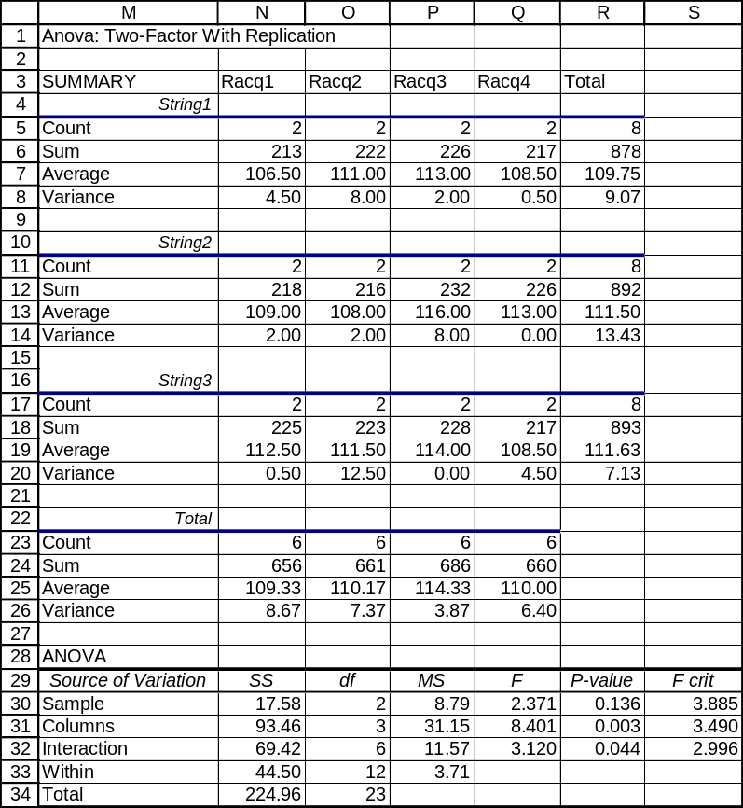

Testing for Main Effects, Factor A (type of string)
H₀: α_{i} = 0 for each value of i, i = 1 through 3
H₁: α_{i} ≠ 0 for at least one value of i
The calculated test statistic is F = 2.371. The p-value is 0.136, which is not < α = 0.05.
Do not reject H₀. At the 0.05 level, we conclude that the three string types are equally effective.

Testing for Main Effects, Factor B (type of racquet)
H₀: β_{j} = 0 for each value of j, j = 1 through 4
H₁: β_{j} ≠ 0 for at least one value of j
The calculated test statistic is F = 8.401. The p-value is 0.003, which is < α = 0.05. Reject H₀. At the 0.05 level, we conclude that at least one of the racquets differs from the others in terms of its effect on the speed of the serve. Therefore, Ted can tell Luke that it does matter which type of racquet is used.

Testing for Interaction Effects
H₀: (αβ)_{ij} = 0 for each combination of i and j
H₁: (αβ)_{ij} ≠ 0 for at least one combination of i and j
The calculated test statistic is F = 3.120. The p-value for this test is 0.044, which is < α = 0.05.
Reject H₀. At the 0.05 level, there is some relationship between the type of string and the type of
racquet. Ted can tell Luke that it does matter which type of string goes into which racquet.

To further examine the combinations of strings and racquets, we will use the cell means (shown in the Excel printout) in plotting the interactions:
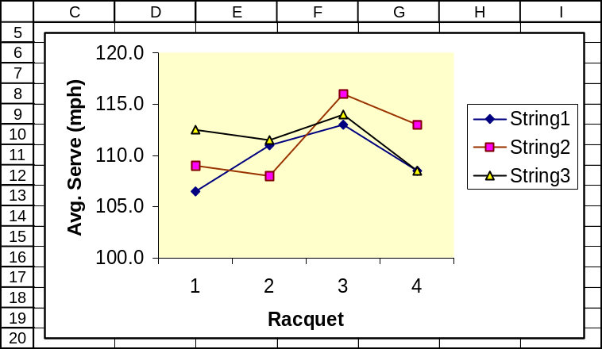

Since the lines are not parallel, there is some interaction present between the type of string and the type of racquet. The average speed of the serve appears to be highest when the second type of string and the third type of racquet are combined. We would recommend that Kermit use this combination.

SPRINGDALE SHOPPING SURVEY

PART I: ATTITUDE COMPARISONS BASED ON THE GENDER OF THE RESPONDENT

1. Comparing the means for variable 7, attitude toward Springdale Mall.

One-way ANOVA: SPRILIKE versus RESPGEND
Analysis of Variance for SPRILIKE
Source DF SS MS F P
RESPGEND 1 0.456 0.456 0.75 0.386
Error 148 89.418 0.604
Total 149 89.873
Individual 95% CIs For Mean
Based on Pooled StDev
Level N Mean StDev ------+---------+---------+---------+
1 58 4.0172 0.7373 (-------------*------------)
2 92 4.1304 0.8013 (---------*----------)
------+---------+---------+---------+
Pooled StDev = 0.7773 3.90 4.05 4.20 4.35

The p-value of 0.386 is not less than the specified level of significance for the test (0.05). At the 0.05 level, we conclude that the population means could be the same. Male and female respondents could have the same attitude toward Springdale Mall.

2. Repeating step 1 for variable 8, attitude toward Downtown.

One-way ANOVA: DOWNLIKE versus RESPGEND
Analysis of Variance for DOWNLIKE
Source DF SS MS F P
RESPGEND 1 0.001 0.001 0.00 0.977
Error 148 131.439 0.888
Total 149 131.440
Individual 95% CIs For Mean
Based on Pooled StDev
Level N Mean StDev --+---------+---------+---------+----
1 58 3.5172 0.9030 (---------------*----------------)
2 92 3.5217 0.9662 (------------*------------)
--+---------+---------+---------+----
Pooled StDev = 0.9424 3.30 3.45 3.60 3.75

The p-value of 0.977 is not less than the specified level of significance for the test (0.05). At the 0.05 level, we conclude that the population means could be the same. Male and female respondents could have the same attitude toward Downtown.

3. Repeating step 1 for variable 9, attitude toward West Mall.

One-way ANOVA: WESTLIKE versus RESPGEND
Analysis of Variance for WESTLIKE
Source DF SS MS F P
RESPGEND 1 0.79 0.79 0.73 0.395
Error 148 161.08 1.09
Total 149 161.87
Individual 95% CIs For Mean
Based on Pooled StDev
Level N Mean StDev ------+---------+---------+---------+
1 58 3.155 1.105 (-------------*------------)
2 92 3.304 1.003 (----------*----------)
------+---------+---------+---------+
Pooled StDev = 1.043 3.00 3.20 3.40 3.60

The p-value of 0.395 is not < the 0.05 level of significance specified for the test. At the 0.05 level, the population means could be the same. Male and female respondents could have the same attitude toward West Mall.

PART II. ATTITUDE COMPARISONS BASED ON EDUCATION LEVEL

1. Comparing the means for variable 7, attitude toward Springdale Mall.

One-way ANOVA: SPRILIKE versus RESPEDUC
Analysis of Variance for SPRILIKE
Source DF SS MS F P
RESPEDUC 3 4.095 1.365 2.32 0.077
Error 146 85.778 0.588
Total 149 89.873
Individual 95% CIs For Mean
Based on Pooled StDev
Level N Mean StDev -+---------+---------+---------+-----
1 4 4.2500 0.9574 (--------------*--------------)
2 38 4.3421 0.7453 (----*----)
3 67 4.0448 0.7268 (---*---)
4 41 3.9024 0.8308 (----*----)
-+---------+---------+---------+-----
Pooled StDev = 0.7665 3.50 4.00 4.50 5.00

The p-value of 0.077 is not less than the specified level of significance for the test (0.05). At the 0.05 level, we conclude that the population means could be the same. Respondents at the four education levels may have the same attitude toward Springdale Mall.

2. Comparing the means for variable 8, attitude toward Downtown.

One-way ANOVA: DOWNLIKE versus RESPEDUC
Analysis of Variance for DOWNLIKE
Source DF SS MS F P
RESPEDUC 3 5.575 1.858 2.16 0.096
Error 146 125.865 0.862
Total 149 131.440
Individual 95% CIs For Mean
Based on Pooled StDev
Level N Mean StDev ------+---------+---------+---------+
1 4 3.0000 1.1547 (--------------*--------------)
2 38 3.2632 1.0050 (----*----)
3 67 3.5672 0.9882 (--*---)
4 41 3.7317 0.7080 (----*----)
------+---------+---------+---------+
Pooled StDev = 0.9285 2.40 3.00 3.60 4.20
The p-value of 0.096 is not less than the specified level of significance for the test (0.05). At the 0.05 level, we conclude that the population means could be the same. Respondents at the four education levels may have the same attitude toward Downtown.

3. Comparing the means for variable 9, attitude toward West Mall.

One-way ANOVA: WESTLIKE versus RESPEDUC
Analysis of Variance for WESTLIKE
Source DF SS MS F P
RESPEDUC 3 6.21 2.07 1.94 0.126
Error 146 155.66 1.07
Total 149 161.87
Individual 95% CIs For Mean
Based on Pooled StDev
Level N Mean StDev ---------+---------+---------+-------
1 4 3.500 0.577 (----------------*----------------)
2 38 3.579 1.056 (-----*----)
3 67 3.134 0.903 (---*---)
4 41 3.098 1.221 (-----*----)
---------+---------+---------+-------
Pooled StDev = 1.033 3.00 3.60 4.20

The p-value of 0.126 is not less than the specified level of significance for the test (0.05). At the 0.05 level, we conclude that the population means could be the same. Respondents at the four education levels may have the same attitude toward West Mall.

BUSINESS CASE

FASTEST COURIER IN THE WEST

1. Examining whether the population mean delivery times for all three couriers might be the same,
we will use the 0.05 level of significance and perform a one-way analysis of variance. The Minitab printout is shown below.

One-way ANOVA: Delivery Time versus Courier
Source DF SS MS F P
Courier 2 3204 1602 7.20 0.001
Error 179 39835 223
Total 181 43039

S = 14.92 R-Sq = 7.44% R-Sq(adj) = 6.41%

Individual 95% CIs For Mean Based on
Pooled StDev
Level N Mean StDev -----+---------+---------+---------+----
1 56 26.21 16.09 (------*-------)
2 65 31.52 13.63 (------*------)
3 61 36.69 15.12 (------*-------)
-----+---------+---------+---------+----
25.0 30.0 35.0 40.0
Pooled StDev = 14.92

From this one-way ANOVA, we see that Metro Delivery (courier #3) had the longest mean delivery time (36.69 minutes) and DFW Express had the shortest (26.21). The p-value for the test is 0.001. Because p-value = 0.001 is < 0.05 level of significance for the test, we reject the null hypothesis that the population mean delivery times could be equal for the three companies. If we were using mean delivery time as the sole criterion, we would recommend that the law firm switch to DFW Express.

2. Examining whether the population mean delivery distances for all three couriers might be the same, we will use the 0.05 level of significance and perform a one-way analysis of variance. The Minitab printout is shown below.

One-way ANOVA: Mileage versus Courier
Source DF SS MS F P
Courier 2 476.3 238.1 10.48 0.000
Error 179 4066.7 22.7
Total 181 4543.0

S = 4.766 R-Sq = 10.48% R-Sq(adj) = 9.48%

Individual 95% CIs For Mean Based on
Pooled StDev
Level N Mean StDev --------+---------+---------+---------+-
1 56 9.696 4.651 (-----*------)
2 65 12.077 4.842 (----*-----)
3 61 13.721 4.789 (-----*-----)
--------+---------+---------+---------+-
10.0 12.0 14.0 16.0
Pooled StDev = 4.766

In part 1, we found that Metro Delivery had the longest mean delivery time, 36.69 minutes.
However, in this analysis, we find that Metro Delivery also has the longest mean delivery distance as well. Thus, we may wish to reconsider the recommendation we made strictly on the basis of the analysis in part 1. The p-value for the test is displayed as 0.000. Because p-value = 0.000 is < 0.05 level of significance for the test, we reject the null hypothesis that the population mean delivery distances could be equal for the three companies.

3. We will now create a new variable called “Average Speed” by dividing “Mileage” by “Delivery Time.” For each delivery, this will be the average speed, measured in miles per minute. Examining whether the population mean delivery average speeds for all three couriers might be the same, we will use the 0.05 level of significance and perform a one-way analysis of variance. The Minitab printout is shown below.

One-way ANOVA: Avg_Speed versus Courier
Source DF SS MS F P
Courier 2 0.00527 0.00264 0.56 0.573
Error 179 0.84363 0.00471
Total 181 0.84890

S = 0.06865 R-Sq = 0.62% R-Sq(adj) = 0.00%

Individual 95% CIs For Mean Based on
Pooled StDev
Level N Mean StDev -----+---------+---------+---------+----
1 56 0.39857 0.07954 (-----------*-----------)
2 65 0.39267 0.06736 (----------*----------)
3 61 0.38519 0.05849 (-----------*----------)
-----+---------+---------+---------+----
0.375 0.390 0.405 0.420
Pooled StDev = 0.06865

The p-value for the test is displayed as 0.573. Because p-value = 0.573 is not < 0.05 level of significance for the test, we do not reject the null hypothesis that the population mean average speeds could be equal. Based on our data, we conclude that the population average speeds could be the same for the three courier firms. On the basis of this analysis, and considering those in parts 1 and 2, the law firm may want to continue using Metro Delivery. Although this courier had the longest mean delivery time, it also had the longest mean delivery distance, and its mean delivery speed (miles/minute) was only slightly slower than the other two firms (0.38519 versus 0.39857 and 0.39267 miles/minute, respectively).

4. Overall, considering the analyses performed above, there appears to be no conclusive evidence that would lead the law firm to switch from their present courier. In the absence of such evidence, we would recommend that Metro Delivery be retained as the firm’s delivery courier.

(Note: If there is concern regarding length of time for a courier agent to arrive after the order is phoned in, we could also carry out a one-way ANOVA examining the possibility of equal means for this variable as well. The result is shown below, and p-value = 0.949 is not < 0.05 level of significance for the test, indicating that the mean pickup times for the three couriers could be the same. Again, there is no evidence to suggest that the law firm should switch couriers.)

One-way ANOVA: Pickup Time versus Courier
Source DF SS MS F P
Courier 2 3.5 1.7 0.05 0.949
Error 179 5880.6 32.9
Total 181 5884.1

S = 5.732 R-Sq = 0.06% R-Sq(adj) = 0.00%

Individual 95% CIs For Mean Based on
Pooled StDev
Level N Mean StDev ---+---------+---------+---------+------
1 56 15.518 6.450 (--------------*--------------)
2 65 15.400 5.881 (-------------*-------------)
3 61 15.180 4.794 (--------------*-------------)
---+---------+---------+---------+------
14.0 15.0 16.0 17.0
Pooled StDev = 5.732

